EPPO Datasheet: Apple fruit crinkle viroid
Last updated: 2021-07-28

IDENTITY
Preferred name: Apple fruit crinkle viroid  Taxonomic position: Viruses and viroids: Viroids: Pospiviroidae: Apscaviroid  Other scientific names: AFCVd, Apple fruit crinkle apscaviroid  view more common names online...  EU Categorization: A1 Quarantine pest (Annex II A)  view more categorizations online...  EPPO Code: AFCVD0 | 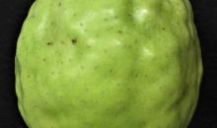  more photos...

Notes on taxonomy and nomenclature
AFCVd is an unclassified viroid in the genus Apscaviroid. Indeed, based on structural features [a central conserved region (CCR) identical to that of the other members of the genus Apscaviroid, with which it also shares the terminal conserved region (TCR)], AFCVd should be classified in the genus Apscaviroid. However, its classification at species level is still tentative. The current criteria, established by the International Committee on Taxonomy of Viruses, to create a novel viroid species, are i) less than 90% sequence identity (over the entire genome) between the viroid to be classified and the other viroids and ii) at least one divergent biological feature with respect to the members of the closest viroid species (Di Serio et al., 2020). AFCVd shares the highest sequence identity (89.4%%) with Australian grapevine viroid (AGVd, species Australian grapevine viroid, genus Apscaviroid), but no evidence has been provided so far that AFCVd diverges from AGVd from a biological point of view, explaining its still partially unresolved taxonomic status.

HOSTS
AFCVd was initially identified from apple trees (Malus domestica) in Japan (Ito et al., 1993). It was later identified, again in Japan, in natural infections of hop (Humulus lupulus) (Sano et al., 2004) and of oriental persimmon (Diospyros kaki) (Nakaune and Nakano, 2008). Research involving germplasm material in the USA (Lin et al., 2011) indicates that pear (Pyrus communis) is an experimental host and suggests that it is also a natural host. However, it is unclear whether the detection of natural infection in pear, performed by molecular hybridization, was confirmed by another technique. The status of pear as a natural host should therefore be considered as still doubtful and not unambiguously established.
By mechanical inoculation, cucumber (Cucumis sativus) and tomato (Solanum lycopersicum) have been shown to be experimental hosts of AFCVd (Suzuki et al., 2017).
Host list: Diospyros kaki, Diospyros virginiana, Humulus lupulus, Malus domestica

GEOGRAPHICAL DISTRIBUTION
Almost all reports of AFCVd are from Japan. The presence of AFCVd in oriental persimmon in Georgia (United States of America) has been documented by Gregory et al. (2018). There also exists a report of the presence of AFCVd in apple in the Xinjiang province of China (Zhao & Niu, 2009). However, the Genbank AFCVd sequence accessions associated with this report do not appear in Genbank, while the detection appears to rely on a single PCR technique. Taken together, the presence of AFCVd in China should be considered as doubtful.
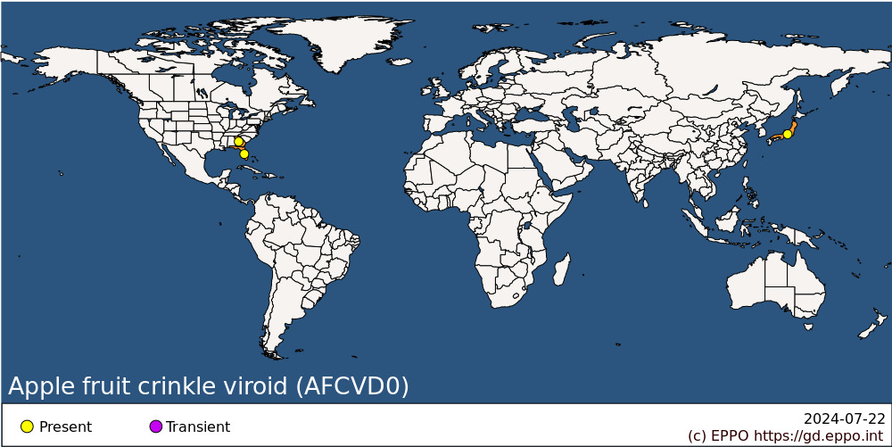
Asia: Japan (Honshu)
North America: United States of America (Florida, Georgia)

BIOLOGY
AFCVd has been transmitted to apple seedlings by grafting, budding or razor-slashing inoculation using purified RNA preparations (Ito et al., 1993). Similar to the other members of the family Pospiviroidae, it is assumed that AFCVd replicates in the nucleus of host plants, moves locally through plasmodesmata and systemically invades the plants through their phloem, leading to generalized infection (Flores et al., 2009). As for most viroids, the natural mode of spread from plant to plant, if any, is still unclear. In apple, natural spread to neighbouring trees has not been documented. AFCVd is however efficiently transmitted by vegetative propagation techniques such as budding or grafting (Koganezawa & Ito, 2011). In hop, AFCVd transmission is also possible through cuttings and mechanical injury during cultural operations (Di Serio et al., 2017).

DETECTION AND IDENTIFICATION

Symptoms
In apple, characteristic symptoms on sensitive varieties consist of crinkled and roughened fruits (Ito et al., 1993; Ito & Yoshida, 1998). In severe cases, fruit crinkling is associated with internal fruit flesh browning, pitting and necrosis. Dappling in the form of discoloured, sometimes slightly depressed, spots is also observed on the fruits of red-skinned cultivars (Koganezawa & Ito, 2011). In the most affected varieties, fruits also tend to drop prematurely. In some varieties, fruits may be smaller, in the absence of other obvious symptoms. Blistering of the bark is also observed in some varieties. Infection is however symptomless in some varieties and no leaf symptoms are observed in any variety (Koganezawa & Ito, 2011).
In hop, an association of AFCVd infection with dwarfing of plants and leaf curling has been suggested, together with a reduction in alpha acid content of hop cones (Sano et al., 2004). Whether AFCVd induces symptoms in infected oriental persimmon remains doubtful (Nakaune & Nakano, 2008; Gregory et al., 2018).

Morphology
AFCVd is a small, circular, naked single-stranded RNA molecule of ~370 nucleotides. As for other members of the family Pospiviroidae, AFCVd genomic molecule lacks ribozymes, adopts a rod-shape secondary structure and contains a central conserved region (CCR) and a terminal conserved region (TCR) (Flores et al., 2009).

Detection and inspection methods
In apple orchards, visual inspections should be carried out on fruit-bearing trees. The visual examination of apples after harvest can also allow the detection of symptoms. However, the practicality of the use of visual examination is dependent on the circumstances (e.g. cultivar and environmental conditions). AFCVd can be detected by indexing on fruit-bearing trees of susceptible varieties (Koganezawa & Ito, 2011), but the test can take up to two years to yield results. Detection can more readily be achieved using either molecular hybridization with molecular probes (Lin et al., 2011) or reverse-transcription polymerase chain reaction (RT-PCR) (Gregory et al., 2018).

PATHWAYS FOR MOVEMENT
In the apparent absence of vectors or of other modes of transmission, movement and trade of contaminated propagation materials is seen as the most significant, if not unique, mode of long-distance movement. Vegetative propagation techniques and cultural operations are the mean of short distance dispersal. Apple fruits are not considered a pathway.

PEST SIGNIFICANCE

Economic impact
While the symptoms induced by AFCVd on sensitive apple cultivars and on hop plants can be severe, the geographic distribution at world scale appears to be very limited. Distribution in Japan, the main country where AFCVd is reported, appears also to be quite limited. Overall, the current economic impact of AFCVd appears very limited.

Control
Given the inefficiency of any known natural spread mechanism, the most efficient control strategy appears to be the development and use of AFCVd-free propagation materials (Koganezawa & Ito, 2011). No known control measures are known in the field, besides the destruction of infected plants, which has proven its efficacy in Japan (Koganezawa & Ito, 2011).

Phytosanitary risk
The phytosanitary risk is essentially linked to infected propagation material and seen as relatively limited given the limited geographical distribution of AFCVd and the apparently inefficient (apple, persimmon) or relatively inefficient (hop) spread in the field. EFSA (2019) considered that climatic conditions in the EPPO region would not impair establishment. However, symptom expression and severity may be affected by climatic conditions (e.g. temperature and light) and by the varieties used.

PHYTOSANITARY MEASURES
Appropriate phytosanitary measures to import apple, oriental persimmon or hop plants for planting into the EPPO region could require that these plants are produced in a pest free area, in a pest free place/site of production, or shown to be free from AFCVd by appropriate molecular diagnostic methods. A number of EPPO countries (e.g. EU countries: Annex VI, points 8 & 9 of Regulation 2019/2072 (EU, 2019)) already ban the import of apple plants for planting (other than seeds) from listed countries including Japan. Host plants for planting could also be imported through post-entry quarantine (in the framework of a bilateral agreement).

REFERENCES
Di Serio F, Owens RA, Li SF, Matoušek J, Pallás V, Randles JW, Sano T, Verhoeven JTJ, Vidalakis G & Flores R (2020) ICTV Report Consortium. ICTV Virus Taxonomy Profile: Pospiviroidae. Journal of General Virology 102(2), 001543.
Di Serio F, Torchetti EM, Flores R & Sano T (2017) Other apscaviroids infecting pome fruit trees. In Viroids and Satellites (eds Hadidi A, Flores R, Randles JW & Palukaitis P), pp. 229-241. Elsevier Academic Press, London (UK).
EFSA PLH (2019) EFSA Plant Health Panel, Bragard C, Dehnen-Schmutz K, Gonthier P, Jacques M-A, Jaques Miret JA, Justesen AF, MacLeod A, Magnusson CS, Milonas P, Navas-Cortes JA, Parnell S, Potting R, Reignault PL, Thulke H-H, Van der Werf W, Vicent Civera A, Yuen J, Zappala L, Candresse T, Chatzivassiliou E, Finelli F, Winter S, Chiumenti M, Di Serio F, Kaluski T, Minafra A & Rubino L. Scientific Opinion on the pest categorisation of non-EU viruses and viroids of Cydonia Mill, Malus Mill. and Pyrus L. EFSA Journal 17, 5590, 81 pp.
EU (2019) Commission implementing regulation 2019/2072 of 28 November 2019 establishing uniform conditions for the implementation of Regulation (EU) 2016/2031 of the European Parliament and the Council, as regards protective measures against pests of plants, and repealing Commission Regulation (EC) No 690/2008 and amending Commission Implementing Regulation (EU) 2018/2019. Version of 2019-12-10. Official Journal of the European Union L319, 1-278.
Flores R, Gas ME, Molina-Serrano D, Nohales MA, Carbonell A, Gago S, Dela Pena M & Daros JA. (2009) Viroid replication: rolling-circles, enzymes and ribozymes. Viruses 1, 317-334.
Gregory A, Scott SW, Brannen PM & Royal DC (2018) Graft-transmissible agents in oriental persimmons (Diospyros kaki L) in the southeastern USA. Australasian Plant Disease Notes 13, 22.
Ito T, Kanematsu S, Koganezawa H, Tsuchizaki T & Yoshida K (1993) Detection of a viroid associated with apple fruit crinkle disease. Annals of the Phytopathological Society of Japan 59, 520-527.
Ito T & Yoshida K (1998) Reproduction of apple fruit crinkle disease symptoms by apple fruit crinkle viroid. Acta Horticulturae 472, 587-594.
Koganezawa H & Ito T (2011) Apple fruit crinkle viroid. In Viroids, (eds Hadidi A, Flores R, Randles JW & Semancik JS), pp. 150-152. CSIRO Publishing, Collingwood (AU).
Lin L, Li R, Mock R & Kinard G (2011) Development of a polyprobe to detect six viroids of pome and stone fruit trees. Journal of Virological Methods 171, 91-97.
Nakaune R & Nakano M (2008) Identification of a new Apscaviroid from Japanese persimmon. Archives of Virology 153, 969-972.
Sano T, Yoshida H, Goshono M, Monma T, Kawasaki H & Ishizaki K (2004) Characterization of a new viroid strain from hops: evidence for viroid speciation by isolation in different host species. Journal of General Plant Pathology 70, 181-187.
Suzuki T, Fujibayashi M, Hataya T, Taneda A, He YH, Tsushima T, Duraisamy GS, Siglova K, Matousek J & Sano T (2017) Characterization of host-dependent mutations of apple fruit crinkle viroid replicating in newly identified experimental hosts suggests maintenance of stem-loop structures in the left-hand half of the molecule is important for replication. Journal of General Virology 98, 506-516.
Zhao Y & Niu JX (2009) Detection of apple fruit crinkle viroid in Xinjiang apple and its specific fragment sequence analysis. Journal of Agricultural Biotechnology 17, 164-169.

ACKNOWLEDGEMENTS
This datasheet was prepared in 2021 by Drs Francesco di Serio and Thierry Candresse. Their valuable contribution is gratefully acknowledged.

How to cite this datasheet?
EPPO (2024) Apple fruit crinkle viroid. EPPO datasheets on pests recommended for regulation. Available online. https://gd.eppo.int

Datasheet history
This datasheet was first published online in 2021. It is maintained in an electronic format in the EPPO Global Database. The sections on 'Identity', ‘Hosts’, and 'Geographical distribution' are automatically updated from the database. For other sections, the date of last revision is indicated on the right.

