EPPO Datasheet: Bactrocera caryeae
Last updated: 2020-09-23

IDENTITY
Preferred name: Bactrocera caryeae
Authority: (Kapoor)
Taxonomic position: Animalia: Arthropoda: Hexapoda: Insecta: Diptera: Tephritidae
Other scientific names: Dacus caryeae Kapoor
view more common names online...
EPPO Categorization: A1 list
view more categorizations online...
EPPO Code: BCTRCR

Notes on taxonomy and nomenclature
Bactrocera caryeae belongs to the B. dorsalis species complex (see Drew & Hancock, 1994).

HOSTS
This pest species is known from a limited but varied range of hosts, including several commercial crops. However, because of possible confusion with B. dorsalis, several older records need confirmation.
Host list: Aegle marmelos, Artocarpus integer, Careya arborea, Casimiroa edulis, Citrus maxima, Citrus x aurantium var. tangerina, Citrus, Malpighia emarginata, Mangifera indica, Persea americana, Pouteria sapota, Psidium guajava, Syzygium jambos

GEOGRAPHICAL DISTRIBUTION
This species is restricted to southern part of the Indian Subcontinent. Although some sources indicate that the species is present in Sri Lanka, Drew & Romig (2013) state explicitly that the earlier recorded presence in Sri Lanka is erroneous.
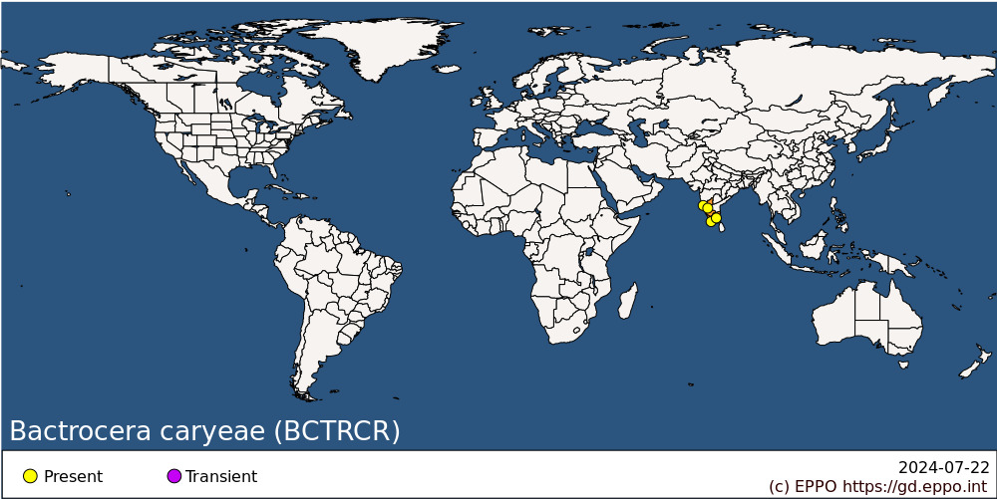
Asia: India (Goa, Karnataka, Kerala, Tamil Nadu)

BIOLOGY
Little is known about the biology of B. caryeae. The general life cycle is considered similar to those of other Bactrocera species infesting fruits: eggs are laid below the skin of the host fruit. Three larval stages develop inside the fruit, feeding on the plant tissue. Once mature the third instar larva will leave the fruit, dig down into the soil and turn into a pupa enclosed in a puparium. The adult fly will emerge from the puparium. No information is available regarding the duration of the life cycle or the environmental requirements.

DETECTION AND IDENTIFICATION

Symptoms
Attacked fruit have tiny oviposition punctures, but these and other symptoms of damage are often difficult to detect in the early stages of infestation. Considerable damage may occur inside the fruit before symptoms are visible externally, often as networks of tunnels accompanied by rotting.

Morphology
Larva
Fruit fly larvae in general have a typical shape, i.e., cylindrical maggot-shape, elongate, anterior end narrowed and somewhat recurved ventrally, with anterior mouth hooks, and flattened caudal end. Their length varies from 5 to 15 mm. Identification to species level is not possible based on larvae. A key for the 3rd-instar larvae is available in White & Elson- Harris (1992) and is useful for identification to the genus level. The larvae of B. caryeae have not been described in detail.
Adult (after diagnostic description given by Drew & Romig, 2013. Additional character states of the female after Drew & Hancock, 1994)
Male
Face fulvous with a pair of large elongate oval black spots; postpronotal lobes yellow (except anterodorsal corners fuscous); notopleura yellow; scutum black with a small area of dark brown posterolateral to lateral postsutural vittae; narrow lateral postsutural yellow vittae which are either parallel sided or narrowing slightly posteriorly to end at or just before intra-alar seta; medial postsutural yellow vitta absent; mesopleural stripe reaching midway between anterior margin of notopleuron and anterior notopleural seta dorsally; scutellum yellow with a broad black basal band; legs with femora fulvous with a large dark fuscous to black preapical spot on outer surfaces of fore femora and inner surfaces of mid and hind femora; fore tibiae fuscous, mid tibiae fulvous, hind tibiae dark fuscous; wing with cells bc and c colourless, sparse microtrichia in outer corner of cell c only; a very narrow fuscous costal band confluent with R2+3 and remaining very narrow around apex of wing; a narrow fuscous anal streak contained within cell cup; supernumerary lobe of medium development; abdominal terga III-V orange-brown with dark fuscous to black across anterior one-third to one-half of tergum III, two broad lateral longitudinal dark fuscous to black bands and a narrow medial longitudinal black band over all three terga, a pair of oval orange-brown shining spots on tergum V; abdominal sterna dark coloured.
Female
As for male in the general body colour patterns. Wing, supernumerary lobe weak; pecten absent from abdominal tergum III. Ovipositor basal segment fuscous, dorsoventrally compressed and tapering posteriorly in dorsal view; ratio of length of oviscape to length of tergum V, 0.78:1; aculeus apex needle shaped.
Remark: differentiation between this species and closely related species within the B. dorsalis species complex is difficult and needs expert confirmation. See ISPM 27 DP 29(IPPC, 2019) for details on how to differentiate between the main species of commercial importance belonging to the species complex.

DNA barcoding
The molecular identification of B. caryeae through DNA barcoding (COI) proves to be problematic as this species cannot be properly resolved from a number of closely related species, including species from the B. dorsalis species complex (see ISPM 27 DP 29 - IPPC, 2019). Additionally, the presence of unidentified / possibly misidentified reference sequence in BINs in which this species is represented, might also bias its molecular ID. Sequences are available in the Barcode of Life Data Systems (BOLD).

Detection and inspection methods
Males are attracted to methyl eugenol. Both sexes can also be monitored by traps baited with protein based attractants. Detection is also possible by examination of fruit for oviposition punctures and then rearing the larvae through to the adult stage.

PATHWAYS FOR MOVEMENT
Transport of infested fruits is the main means of movement and dispersal to previously uninfested areas. Adult flight can also result in dispersal but previous citations of long (50-100 km) dispersal movements for Bactrocera spp. are unsubstantiated according to a recent review by Hicks et al. (2019). Dispersal up to 2 km is considered more typical.

PEST SIGNIFICANCE

Economic impact
Ramani et al. (2008) mention mango and guava as the main commercial hosts.

Control
Management for this species includes the general control measures for Bactrocera spp. (see Vargas et al., 2015 for a recent overview of management options). These include sanitation (to gather all fallen and infested host fruits and destroy them). Insecticidal protection is possible by using a cover spray or a bait spray. Bait sprays work on the principle that both male and female tephritids are strongly attracted to a protein source from which ammonia emanates. Bait sprays have the advantage over cover sprays in that they can be applied as a spot treatment so that the flies are attracted to the insecticide and there is minimal impact on natural enemies and other beneficials.

Phytosanitary risk
Bactrocera caryeae is a known pest of commercial fruit crops in the area where it is present. It can be moved in trade with infested fruit. No detailed study has been made on climatic suitability of the EPPO region for this species, and it is unclear whether it could become established in the EPPO region. Transient populations could also impact export of host fruit from the EPPO region. The EFSA Panel on Plant Health, in their Pest Categorization of non-EU Tephritidae (EFSA, 2020) placed B. caryeae on the list of fruit flies that satisfy the criteria to be regarded as a potential Union quarantine pest for the EU.

PHYTOSANITARY MEASURES
Consignments of fruits from countries or regions where B. caryeae occurs should be inspected for symptoms of infestation and those suspected should be cut open in order to look for larvae. Possible measures include that such fruits should come from an area where B. caryeae does not occur, or from a place of production found free from the pest by regular inspection in the 3 months before harvest. Plants transported with roots from countries or regions where B. caryeae occurs should be free from soil, or the soil should be treated against puparia. The plants should not carry fruits.

REFERENCES
EFSA PLH Panel (EFSA Panel on Plant Health), Bragard C, Dehnen-Schmutz K, Di Serio F, Gonthier P, Jacques MA, Jaques Miret JA, Justesen AF, Magnusson CS, Milonas P, Navas-Cortes JA, Parnell S, Potting R, Reignault PL, Thulke HH, Van der Werf W, Vicent Civera A, Yuen J, Zappalà L, Bali EM, Papadopoulos N, Papanastassiou S, Czwienczek E & MacLeod A (2020) Pest categorization of non-EU Tephritidae. EFSA Journal 18: 5931, 62pp. https://doi.org/10.2903/j.efsa.2020.5931
Drew RAI & Hancock DL (1994) The Bactrocera dorsalis complex of fruit flies (Diptera: Tephritidae: Dacinae) in Asia. Bulletin of Entomological Research suppl. Series 2, 1-68.
Drew RAI & Romig MC (2013) Tropical Fruit Flies of South-East Asia. CABI, Wallingford, vii+653pp.
Hicks CB, Bloem K, Pallipparambil GR & Hartzog HM (2019) Reported long-distance flight of the invasive Oriental fruit fly and its trade implications. In Area-Wide Management of Fruit Flies (eds Pérez-Staples D, Diaz-Fleischer F, Montoya P. & Vera MT), pp. 9-26. CRC Press, Boca Raton (US)
IPPC ( 2019). ISPM 27 Diagnostic protocols for regulated pests DP 29: Bactrocera dorsalis. International Plant Protection Convention, FAO, Rome (Italy), 39pp.
Ramani S, David KJ, Viraktamath CA & Kumar ARV (2008) Identity and distribution of Bactrocera caryeae (Kapoor) (Insecta: Diptera: Tephritidae) A species under the Bactrocera dorsalis complex in India. Biosystematica 2, 49-57.
Vargas RI, Pinero JC & Leblanc L (2015) An overview of pest species of Bactrocera fruit flies (Diptera: Tephritidae) and the integration of biopesticides with other biological approaches for their management with a focus on the Pacific region. Insects 6, 297-318.
White IM & Elson-Harris MM (1992) Fruit flies of economic significance: their identification and bionomics. CAB International, Wallingford, xii+601pp
CABI resources used when preparing this datasheet
CABI Datasheet on Pest https://www.cabi.org/isc/datasheet/8699

ACKNOWLEDGEMENTS
This datasheet was prepared in 2020 by Dr M. de Meyer. His valuable contribution is gratefully acknowledged.

How to cite this datasheet?
EPPO (2024) Bactrocera caryeae. EPPO datasheets on pests recommended for regulation. Available online. https://gd.eppo.int

Datasheet history
This datasheet was first published in 1997 in the second edition of 'Quarantine Pests for Europe', as part of the Bactrocera dorsalis species complex, and revised in 2020. It is now maintained in an electronic format in the EPPO Global Database. The sections on 'Identity', ‘Hosts’, and 'Geographical distribution' are automatically updated from the database. For other sections, the date of last revision is indicated on the right.
CABI/EPPO (1997) Quarantine Pests for Europe (2nd edition). CABI, Wallingford (GB).

