EPPO Datasheet: Bactrocera occipitalis
Last updated: 2020-09-23

IDENTITY
Preferred name: Bactrocera occipitalis
Authority: (Bezzi)
Taxonomic position: Animalia: Arthropoda: Hexapoda: Insecta: Diptera: Tephritidae
Other scientific names: Chaetodacus ferrugineus occipitalis (Bezzi), Dacus occipitalis (Bezzi)
view more common names online...
EPPO Categorization: A1 list
view more categorizations online...
EPPO Code: BCTROC

Notes on taxonomy and nomenclature
Bactrocera occipitalis belongs to the B. dorsalis species complex (see Drew & Hancock, 1994).

HOSTS
Known from a limited but varied list of hosts belonging to six different plant families. The USDA Compendium of Fruit Fly Host Information (CoFFHI) (Liquido et al., 2019). provides an extensive host list with detailed references.
Host list: Mangifera indica, Psidium guajava, fruit trees

GEOGRAPHICAL DISTRIBUTION
Bactrocera occipitalis has a restricted distribution and is only recorded from islands in Maritime Southeast Asia, i.e. Borneo Island and the Philippine archipelago. Earlier records of Bactrocera dorsalis being introduced in Palau, appear to also comprise B. occipitalis (see Pacific Fruit Fly Project).
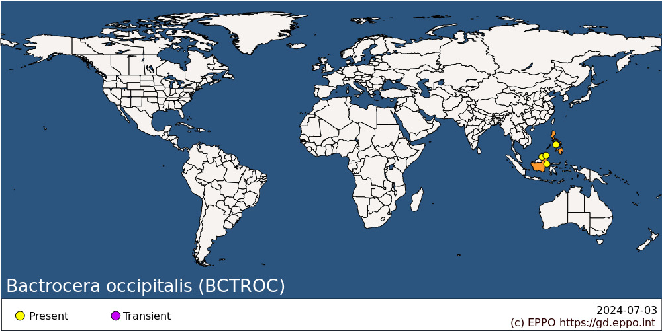
Asia: Brunei Darussalam, Indonesia (Kalimantan), Malaysia (Sabah), Philippines

BIOLOGY
Little is known about the biology of B. occipitalis. The general life cycle is considered similar to those of other Bactrocera species infesting fruits: eggs are deposited inside fruits by the female puncturing the fruit skin. Three larval stages develop inside the fruit, feeding on the plant tissue. Once mature the third instar larva will leave the fruit, dig down into the soil and turn into a pupa enclosed in a puparium. The adult fly will emerge from the puparium. No information is available regarding the duration of the life cycle or the environmental requirements.

DETECTION AND IDENTIFICATION

Symptoms
Attacked fruit have tiny oviposition punctures, but these and other symptoms of damage are often difficult to detect in the early stages of infestation. Considerable damage may occur inside the fruit before symptoms are visible externally, often as networks of tunnels accompanied by rotting.

Morphology
Larva
Fruit fly larvae in general have a typical shape, i.e., cylindrical maggot-shape, elongate, anterior end narrowed and somewhat recurved ventrally, with anterior mouth hooks, and flattened caudal end. Their length varies from 5 to 15 mm. Identification to species level is not possible based on larvae. A key for the 3rd-instar larvae is available in White & Elson- Harris (1992) and is useful for an identification to the genus level. The larvae of B. occipitalis have not been described in detail.
Adult (after diagnostic description given by Drew & Romig, 2013. Additional character states character states of the female after Drew & Hancock, 1994)
Male
Face fulvous with a pair of large oval black spots; postpronotal lobes and notopleura yellow; scutum black except dark red-brown along posterior margin and enclosing prescutellar. setae, below and behind lateral postsutural vittae, around notopleural suture, around anterior margin of notopleura and inside postpronotal lobes; broad parallel-sided or subparallel lateral postsutural yellow vittae ending at intra-alar seta (in some specimens the vittae end behind the intra-alar seta); medial postsutural yellow vitta absent; mesopleural stripe reaching midway between anterior margin of notopleuron and anterior notopleural seta dorsally; scutellum yellow; legs with femora entirely fulvous; fore tibiae pale fuscous to fuscous, mid tibiae pale fuscous to fuscous basally tending paler apically, hind tibiae fuscous; wing with cells bc and c colourless, microtrichia in outer corner of cell c only; a narrow fuscous costal band distinctly overlapping R2+3 and widening markedly across apex of wing; a narrow fuscous anal streak; supernumerary lobe of medium development; abdominal terga III-V with a narrow transverse black band across anterior margin of tergum III and expanding to cover lateral margins, dark fuscous to black rectangular markings anterolaterally of tergum IV which sometimes continue to cover posterolateral margin of this tergum, dark fuscous to black anterolateral corners on tergum V, a very broad medial longitudinal black band over all three terga, a pair of oval orange-brown shining spots on tergum V; abdominal sterna dark coloured.
Female
As for male in the general body colour patterns. Wing, supernumerary lobe weak; pecten absent from abdominal tergum III. Ovipositor basal segment orange-brown, dorsoventrally compressed and tapering posteriorly in dorsal view; ratio of length of oviscape to length of tergum V, 0.68:1; aculeus apex needle shaped.
Remark: differentiation between this species and closely related species within the B. dorsalis species complex is difficult and needs expert confirmation. See ISPM 27 DP 29 (IPPC, 2019) for details on how to differentiate between the main species of commercial importance belonging to the species complex.

DNA barcoding
The molecular identification of B. occipitalis through DNA barcoding (COI) proves to be problematic as this species cannot be properly resolved from a number of closely related species, including species from the B. dorsalis species complex (see ISPM 27 DP 29 - IPPC, 2019). Additionally, the presence of unidentified / possibly misidentified reference sequence in the Barcoding Index Number Systems (BINs) in which this species is represented, might also bias its molecular ID. Sequences are available in the Barcode of Life Data Systems (BOLD).

Detection and inspection methods
Males are attracted to methyl eugenol. Both sexes can be monitored by traps baited with protein-based attractants. Detection is also possible by examination of fruit for oviposition punctures and then rearing the larvae through to the adult stage.

PATHWAYS FOR MOVEMENT
Transport of infested fruits is the main mean of movement and dispersal to previously uninfested areas. Adult flight can also result in dispersal but previous citations of long (50-100 km) dispersal movements for Bactrocera spp. are unsubstantiated according to a recent review by Hicks et al. (2019). Dispersal up to 2 km is considered more typical.

PEST SIGNIFICANCE

Economic impact
The full impact of B. occipitalis is not fully understood because of co-occurrence with other similar species such as B. dorsalis. Although it is reported from a limited number of commercial fruits, no figures are available on the magnitude of infestation.

Control
Management for this species includes the general control measures for Bactrocera spp. (see Vargas et al. 2015 for an overview of management options). These include sanitation (to gather all fallen and infested host fruits and destroy them). Insecticidal protection is possible by using a cover spray or a bait spray. Bait sprays work on the principle that both male and female tephritids are strongly attracted to a protein source from which ammonia emanates. Bait sprays have the advantage over cover sprays in that they can be applied as a spot treatment so that the flies are attracted to the insecticide and there is minimal impact on natural enemies and other beneficials.

Phytosanitary risk
Bactrocera occipitalis is a known pest of peach in the area where it is present. It can be moved in trade with infested fruit. No detailed study has been made on climatic suitability of the EPPO region for this species, and it is unclear whether it could become established in the EPPO region. However, even transient populations could impact export of host fruit from the EPPO region. The EFSA Panel on Plant Health, in their Pest Categorization of non-EU Tephritidae (EFSA, 2020) placed B. occipitalis on the list of fruit flies that satisfy the criteria to be regarded as a potential Union quarantine pest for the EU.

PHYTOSANITARY MEASURES
Consignments of fruits from countries or regions where B. occipitalis occurs should be inspected for symptoms of infestation and those suspected should be cut open in order to look for larvae. Possible measures include that such fruits should come from an area where B. occipitalis does not occur, or from a place of production found free from the pest by regular inspection for 3 months before harvest. Plants transported with roots from countries or regions where B. occipitalis occurs should be free from soil, or the soil should be treated against puparia. The plants should not carry fruits.

REFERENCES
EFSA PLH Panel (EFSA Panel on Plant Health), Bragard C, Dehnen-Schmutz K, Di Serio F, Gonthier P, Jacques MA, Jaques Miret JA, Justesen AF, Magnusson CS, Milonas P, Navas-Cortes JA, Parnell S, Potting R, Reignault PL, Thulke HH, Van der Werf W, Vicent Civera A, Yuen J, Zappalà L, Bali EM, Papadopoulos N, Papanastassiou S, Czwienczek E & MacLeod A (2020) Pest categorization of non-EU Tephritidae. EFSA Journal 18: 5931, 62pp. https://doi.org/10.2903/j.efsa.2020.5931
Drew RAI & Hancock DL (1994) The Bactrocera dorsalis complex of fruit flies (Diptera: Tephritidae: Dacinae) in Asia. Bulletin of Entomological Research suppl. Series 2, 1-68.
Drew RAI & Romig MC (2013) Tropical Fruit Flies of South-East Asia. CABI, Wallingford, vii+653pp.
Hicks CB, Bloem K, Pallipparambil GR & Hartzog HM (2019) Reported long-distance flight of the invasive Oriental fruit fly and its trade implications. In Area-Wide Management of Fruit Flies (eds Pérez-Staples D, Diaz-Fleischer F, Montoya P. & Vera MT), pp. 9-26. CRC Press, Boca Raton (US)
IPPC (2019) ISPM 27 Diagnostic protocols for regulated pests DP 29: Bactrocera dorsalis. International Plant Protection Convention, FAO, Rome (Italy), 39pp.
Liquido, N.J., K.L.K. Lee & J. Santamaria. 2019. Host plant records of Bactrocera occipitalis (Bezzi) (Diptera : Tephritidae), Version 1.0. Available online at USDA Compendium of Fruit Fly Host Information (CoFFHI). https://coffhi.cphst.org/ (accessed 16/05/2020)
Vargas RI, Pinero JC & Leblanc L (2015) An overview of pest species of Bactrocera fruit flies (Diptera: Tephritidae) and the integration of biopesticides with other biological approaches for their management with a focus on the Pacific region. Insects 6, 297-318.
White IM & Elson-Harris MM (1992) Fruit flies of economic significance: their identification and bionomics. CAB International, Wallingford, xii+601pp
CABI resources used when preparing this datasheet
CABI Datasheet on Pest https://www.cabi.org/isc/datasheet/8729

ACKNOWLEDGEMENTS
This datasheet was prepared in 2020 by Dr M. de Meyer. His valuable contribution is gratefully acknowledged.

How to cite this datasheet?
EPPO (2024) Bactrocera occipitalis. EPPO datasheets on pests recommended for regulation. Available online. https://gd.eppo.int

Datasheet history
This datasheet was first published in 1997 in the second edition of 'Quarantine Pests for Europe', as part of the Bactrocera dorsalis species complex, and revised in 2020. It is now maintained in an electronic format in the EPPO Global Database. The sections on 'Identity', ‘Hosts’, and 'Geographical distribution' are automatically updated from the database. For other sections, the date of last revision is indicated on the right.
CABI/EPPO (1997) Quarantine Pests for Europe (2nd edition). CABI, Wallingford (GB).

