EPPO Datasheet: Bactrocera pyrifoliae
Last updated: 2020-09-23

IDENTITY
Preferred name: Bactrocera pyrifoliae
Authority: Drew & Hancock
Taxonomic position: Animalia: Arthropoda: Hexapoda: Insecta: Diptera: Tephritidae
view more common names online...
EPPO Categorization: A1 list
view more categorizations online...
EPPO Code: BCTRPY

Notes on taxonomy and nomenclature
Bactrocera pyrifoliae belongs to the B. dorsalis species complex (see Drew & Hancock, 1994).

HOSTS
Known from a limited but varied list of hosts belonging to five different plant families.
Host list: Baccaurea ramiflora, Macropanax concinnus, Prunus cerasoides, Prunus domestica, Prunus persica, Psidium guajava, Pyrus pyrifolia, Xanthophyllum flavescens

GEOGRAPHICAL DISTRIBUTION
The species is only reported from northern Vietnam and Thailand. According to Khahn et al. (2014) in Vietnam it only occurs at higher elevations (between 1000 and 1500 m a.s.l.).
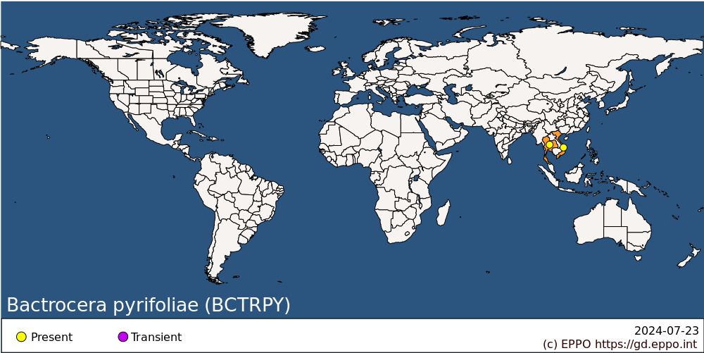
Asia: Thailand, Vietnam

BIOLOGY
Little is known about the biology of B. pyrifoliae. The general life cycle is considered similar to those of other Bactrocera species infesting fruits: eggs are laid below the skin of the host fruit. Three larval stages develop inside the fruit, feeding on the plant tissue. Once mature, the third instar larva will leave the fruit, dig down into the soil and turn into a pupa enclosed in a puparium. The adult fly will emerge from the puparium. Khanh et al. (2014) provides some biological information on B. pyrifoliae, based upon field observations in Vietnam and laboratory experiments. Infested fruits were recovered from mid-June till mid-July. However, fruits collected from hosts located below 1000m in elevation were not infested. In laboratory rearing, the mean duration of the life cycle from egg deposition to adult sexual maturity was 46 days on average, with an average duration for egg, larval and pupal stage of 2.5, 9.7 and 11.5 days respectively.

DETECTION AND IDENTIFICATION

Symptoms
Attacked fruit have tiny oviposition punctures, but these and other symptoms of damage are often difficult to detect in the early stages of infestation. Considerable damage may occur inside the fruit before symptoms are visible externally, often as networks of tunnels accompanied by rotting.

Morphology
Larva
Fruit fly larvae in general have a typical shape, i.e., cylindrical maggot-shape, elongate, anterior end narrowed and somewhat recurved ventrally, with anterior mouth hooks, and flattened caudal end. Their length varies from 5 to 15 mm. Identification to species level is not possible based on larvae. A key for the 3rd-instar larvae is available in White & Elson- Harris (1992) and is useful for an identification to the genus level. The larvae of B. pyrifoliae have not been described in detail.
Adult (after diagnostic description given by Drew & Romig, 2013. Additional character states of the female after Drew & Hancock (1994)
Male
Face fulvous with a pair of medium-sized circular black spots; postpronotal lobes and notopleura yellow; scutum black except dark brown posterolateral to lateral postsutural vittae and dark red-brown anterior to notopleural suture and inside postpronotal lobes; narrow lateral postsutural yellow vittae tapering posteriorly to end before intra-alar seta; medial postsutural yellow vitta absent; mesopleural stripe equal in width to notopleuron dorsally; scutellum yellow; legs with femora fulvous except for a small subapical oval black spot on outer surfaces of fore femora and dark fuscous around apices of mid and hind femora; fore and mid tibiae dark fuscous, hind tibiae black; wing with cells bc and c colourless, microtrichia in outer corner of cell c only; a narrow fuscous costal band confluent with R2+3 and with a slight swelling around apex of R4+5; a narrow fuscous anal streak; supernumerary lobe of medium development; abdominal terga III-V orange-brown and generally with a ‘T’ pattern consisting of a narrow to medium width transverse fuscous to black band across anterior margin of tergum III which expands to cover outer one-third of lateral margins, a narrow to medium width medial longitudinal dark fuscous to black band, tergum V with a narrow to medium width medial longitudinal dark fuscous to black band and dark fuscous to black anterolateral corners which may also meet along anterior margin, a pair of oval dark fuscous shining spots on tergum V; abdominal sterna dark coloured.
Female
As for male in the general body colour patterns. Wing, supernumerary lobe weak; pecten absent from abdominal tergum III. Ovipositor basal segment fuscous, dorsoventrally compressed and tapering posteriorly in dorsal view; ratio of length of oviscape to length of tergum V, 1.2:1; aculeus apex needle shaped.
Remark: differentiation between this species and closely related species within the B. dorsalis species complex is difficult and needs expert confirmation. See ISPM 27 DP 29 (IPPC, 2019) for details on how to differentiate between the main species of commercial importance belonging to the species complex.

DNA barcoding
The molecular identification of B. pyrifoliae through DNA barcoding is currently not possible as no reference sequences are available on the Barcode of Life Data Systems (BOLD).

Detection and inspection methods
Though most Bactrocera spp. can be monitored by traps baited with male lures, B. pyrifoliae is not known to be attracted significantly to any male lure. There may be a weak attraction of males to cue lure according to Drew & Romig (2013), although Nishida and Tan (2016) record a no-lure response. Both sexes can be monitored by traps baited with protein-based attractants. Detection is also possible by examination of fruit for oviposition punctures and then rearing the larvae through to the adult stage.

PATHWAYS FOR MOVEMENT
Transport of infested fruits is the main means of movement and dispersal to previously uninfested areas. Adult flight can also result in dispersal but previous citations of long (50-100 km) dispersal movements for Bactrocera spp. are unsubstantiated according to a recent review by Hicks et al. (2019). Dispersal up to 2 km is considered more typical.

PEST SIGNIFICANCE

Economic impact
Peaches are heavily infested in Northern Vietnam from early June till harvest in mid July (reaching levels up to 100%) according to Khanh et al. (2014) and Vijaysegaran (2016).

Control
Management for this species includes the general control measures for Bactrocera spp. (see Vargas et al. 2015 for an overview of management options). These include sanitation (to gather all fallen and infested host fruits and destroy them). Insecticidal protection is possible by using a cover spray or a bait spray. Bait sprays, using a converted brewery yeast waste product, was used against combined infestation of B. pyrifoliae and B. dorsalis in peach orchards in Northern Vietnam and reduced the damage considerably (from 100% to less than 4%) according to Vijaysegaran (2016). Bait sprays work on the principle that both male and female tephritids are strongly attracted to a protein source from which ammonia emanates. Bait sprays have the advantage over cover sprays in that they can be applied as a spot treatment so that the flies are attracted to the insecticide and there is minimal impact on natural enemies and other beneficials.

Phytosanitary risk
Bactrocera pyrifoliae is a known pest of peach in the area where it is present. It can be moved in trade with infested fruit. No detailed study was made on climatic suitability of the EPPO region for this species, B. pyrifoliae is known to occur at higher altitudes in its native range, which could indicate preference for cooler conditions, corresponding to temperate climate conditions within parts of the EPPO region. Transient populations could also impact export of host fruit from the EPPO region. The EFSA Panel on Plant Health, in their Pest Categorization of non-EU Tephritidae (EFSA, 2020) placed B. pyrifoliae on the list of fruit flies that satisfy the criteria to be regarded as a potential Union quarantine pest for the EU.

PHYTOSANITARY MEASURES
Consignments of fruits from countries or regions where B. pyrifoliae occurs should be inspected for symptoms of infestation and those suspected should be cut open in order to look for larvae. Possible measures include that such fruits should come from an area where B. pyrifoliae does not occur, or from a place of production found free from the pest by regular inspection in the 3 months before harvest. Plants transported with roots from countries or regions where B. pyrifoliae occurs should be free from soil, or the soil should be treated against puparia. The plants should not carry fruits.

REFERENCES
EFSA PLH Panel (EFSA Panel on Plant Health), Bragard C, Dehnen-Schmutz K, Di Serio F, Gonthier P, Jacques MA, Jaques Miret JA, Justesen AF, Magnusson CS, Milonas P, Navas-Cortes JA, Parnell S, Potting R, Reignault PL, Thulke HH, Van der Werf W, Vicent Civera A, Yuen J, Zappalà L, Bali EM, Papadopoulos N, Papanastassiou S, Czwienczek E & MacLeod A (2020) Pest categorization of non-EU Tephritidae. EFSA Journal 18, 5931, 62pp. https://doi.org/10.2903/j.efsa.2020.5931
Drew RAI & Hancock DL (1994) The Bactrocera dorsalis complex of fruit flies (Diptera: Tephritidae: Dacinae) in Asia. Bulletin of Entomological Research suppl. Series 2, 1-68.
Drew RAI & Romig MC (2013) Tropical Fruit Flies of South-East Asia. CABI, Wallingford, vii+653pp.
Hicks CB, Bloem K, Pallipparambil GR & Hartzog HM (2019) Reported long-distance flight of the invasive Oriental fruit fly and its trade implications. In Area-Wide Management of Fruit Flies (eds Pérez-Staples D, Diaz-Fleischer F, Montoya P. & Vera MT), pp. 9-26. CRC Press, Boca Raton (US)
IPPC (2019) ISPM 27 Diagnostic protocols for regulated pests DP 29: Bactrocera dorsalis. International Plant Protection Convention, FAO, Rome (Italy), 39pp.
Khanh LD, Hien NTT, Trang VT, Toan TT & Rull J (2014) Basic biology and artificial rearing of Bactrocera pyrifoliae (Diptera: Tephritidae), a pest of peaches and plums in northern Vietnam. International Journal of Tropical Insect Science 34, 148-153.
Nishida R & Tan K-H (2016) Search for new fruit fly attractants from plants: a review. Proceedings of the 9th ISFFEI, 249-262.
Vargas RI, Pinero JC & Leblanc L (2015) An overview of pest species of Bactrocera fruit flies (Diptera: Tephritidae) and the integration of biopesticides with other biological approaches for their management with a focus on the Pacific region. Insects 6, 297-318.
Vijaysegaran S (2016) Bait manufactured from beer yeast waste and its use for fruit fly management. Proceedings of the 9th ISFFEI, 227-248.
White IM & Elson-Harris MM (1992) Fruit flies of economic significance: their identification and bionomics. CAB International, Wallingford, xii+601pp

ACKNOWLEDGEMENTS
This datasheet was prepared in 2020 by Dr M. de Meyer. His valuable contribution is gratefully acknowledged.

How to cite this datasheet?
EPPO (2024) Bactrocera pyrifoliae. EPPO datasheets on pests recommended for regulation. Available online. https://gd.eppo.int

Datasheet history
This datasheet was first published in 1997 in the second edition of 'Quarantine Pests for Europe', as part of the Bactrocera dorsalis species complex, and revised in 2020. It is now maintained in an electronic format in the EPPO Global Database. The sections on 'Identity', ‘Hosts’, and 'Geographical distribution' are automatically updated from the database. For other sections, the date of last revision is indicated on the right.
CABI/EPPO (1997) Quarantine Pests for Europe (2nd edition). CABI, Wallingford (GB).

