**EPPO Datasheet: *Xyphon fulgidum***

Last updated: 2024-07-30

**IDENTITY**

|  |  |
| --- | --- |
| **Preferred name:** *Xyphon fulgidum* **Authority:** (Nottingham) **Taxonomic position:** Animalia: Arthropoda: Hexapoda: Insecta: Hemiptera: Auchenorrhyncha: Cicadellidae **Other scientific names:** *Carneocephala fulgida* Nottingham, *Xyphon fulgida* (Nottingham) **Common names in English:** red-headed sharpshooter [view more common names online...](https://gd.eppo.int/taxon/CARNFU/) **EU Categorization:** A1 Quarantine pest (Annex II A) [view more categorizations online...](https://gd.eppo.int/taxon/CARNFU/categorization) **EPPO Code:** CARNFU | 327.jpg [more photos...](https://gd.eppo.int/taxon/CARNFU/photos) |

**HOSTS**

*Xyphon fulgidum* occurs mainly on grasses predominantly *Cynodon dactylon* as well as others including *Cyperus esculentus*, *Echinochloa crus-galli*, and *Sorghum halepense*(Daane *et al.*, 2011; Pilkington *et al*., 2005; Wistrom and Purcell, 2005). However, it is also found on weedy vegetation including *Chrysothamnus* sp. and *Trichostema lanceolatum*(Catanach *et al*., 2013). Overall, *X. fulgidum* feeds on a range of hosts, with over 75 species recorded (Hewitt *et al.*, 1949).  The leafhopper occurs both in natural areas and human modified habitats including the margins of agricultural fields and vineyards (Hewitt *et al*., 1949). Although not a typical host, *X. fulgidum* will feed on *Vitis vinifera*particularly plants close to their preferred hosts if they are displaced, for example during crop harvest (Hewitt *et al*., 1949; Purcell and Frazier, 1985).

**Host list:** *Ammannia coccinea*, *Calandrinia ciliata subsp. menziesii*, *Calandrinia ciliata*, *Chrysothamnus sp.*, *Cynodon dactylon*, *Cyperus esculentus*, *Digitaria sanguinalis*, *Distichlis spicata*, *Distichlis stricta*, *Echinochloa crus-galli*, *Echinodorus cordifolius*, *Erodium cicutarium*, *Festuca myuros*, *Gnaphalium chilense*, *Matricaria discoidea*, *Phyla nodiflora*, *Polygonum aviculare*, *Portulaca oleracea*, *Sorghum halepense*, *Tribulus terrestris*, *Trichostema lanceolatum*, *Vitis vinifera*

**GEOGRAPHICAL DISTRIBUTION**

*Xyphon fulgidum* is almost exclusively found in California (US), both in the coastal and inland portion of the state (Catanach *et al*. 2013 and specimen records). However, a few specimen records occur from riparian habitats in Southern Arizona and a single collecting locality in a coastal area of Guerrero, Mexico suggest this species is found in limited regions outside California (specimens deposited in Snow Entomological Museum Collection at the University of Kansas, Lawrence, KS; University of California, Riverside, Riverside, CA; and Smithsonian National Museum of Natural History, Washington DC). Further surveys in riparian areas of the South-Western United States or Mexico could identify additional areas where this species occurs.

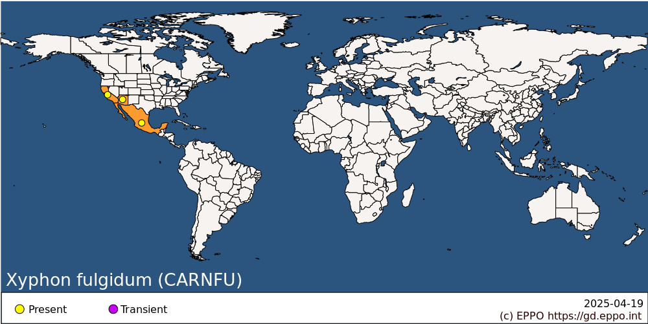 **North America:** Mexico, United States of America (Arizona, California)

**BIOLOGY**

Although little is known about the biology of *X. fulgidum*, a member of *Xyphon’s* sister genus, *Draeculacephala floridana*has been the subject of a detailed natural history study (Rossi and Strong, 1990). For *D*. *floridana* they found that while oviposition occurs on many plant species, one species was much preferred over others. *D*. *floridana* females oviposit clutches of 2-11 (mean approximately 4) eggs under the surface of the epidermis through a single incision, typically on the stem or leaf-base (but in the laboratory occasionally clutches would be deposited on the lower surfaces of the leaves) (Rossi and Strong, 1990). *D*. *floridana* nymphs go through 5 instars and take 4-6 weeks to reach adulthood. On average *D*. *floridana* females lay 93 eggs and survive approximately 33 days. Another relative, *D*. *minerva*, has a similar lifecycle (Freitag, 1951). Based on sweep net data, *D*. *floridana* is thought to be at least bivoltine and have overlapping generations (Rossi and Strong, 2001). Leafhoppers overwinter as either adults or eggs. *D*. *floridana* eggs are parasitised by two species of mymarid wasp (Rossi and Strong, 1990).

**DETECTION AND IDENTIFICATION**

**Symptoms**

Blisters may appear on leaves after oviposition (Rossi and Strong, 1990). Feeding damage from nymphs and adults is typically not visible. However, the insects produce copious watery honeydew and as this dries a white powdery substance is left behind.

**Morphology**

*Eggs*: Eggs of *Xyphon fulgidum* have not been described but the eggs of a close relative, *Draeculacephala floridana*, have been studied both in laboratory and field settings (Rossi and Strong, 1990). Each egg is approximately 1.5 mm in length and a few days after being laid they turn dark green. Over a 12-day period, the eggs change colour as the leafhopper develops. The portion of the egg case with the developing head (side of the egg closest to the oviposition wound) turns cream, a reddish-orange spot representing the compound eye develops and moves around the egg case (reaching its final location at day seven and darkening to black around day nine). First instar nymphs emerge between days 10 and 12, exiting through the oviposition wound.

*Nymph*: Small, pale brownish green to grey. Wing pads with pale streaks running lengthwise.

*Adult*:Green leafhopper with apex of wing densely reticulate (with many crossveins). Head can be marked with light markings or unmarked, but lacks dark markings. Similar to *Xyphon flaviceps* but ocelli very small (distance between ocelli greater than 7 times ocular width and ocelli located more than 2 times ocular width from edge of crown). Female 5.5–6.0 mm; Male 4.5–5.0 mm.

**Detection and inspection methods**

Egg masses are difficult to detect without leaf dissection although a blister may appear. Eyespots (the developing compound eye) may be visible (Rossi and Strong, 1990). Adults and nymphs can be collected via sweep net or vacuum device targeting host vegetation. As *X*. *fulgidum* has been recorded from a variety of plant species sampling weedy vegetation along with crops is recommended.

This species is not attracted to yellow sticky traps, so sampling using a sweep net or vacuum device is recommended (Purcell and Frazier, 1985).

**PATHWAYS FOR MOVEMENT**

As egg masses are deposited below the epidermal surface, they may be undetected prior to transportation of an infested plant. Adults and nymphs may also travel in vegetation (both cut plants and plants for planting), but will be visible upon inspection.

**PEST SIGNIFICANCE**

**Economic impact**

*Xyphon fulgidum* vectors the bacterium *Xylella fastidiosa*(EPPO A2 List of pests recommended for regulation) which is a serious threat to many agriculturally important species. However, in most of its native range it prefers to feed on weedy vegetation or grasses rather than on crops. In North America, outbreaks of *Xylella* *fastidiosa* are thought to result from Glassy-winged Sharpshooter (*Homalodisca vitripennis*) rather than *Xyphon* *fulgidum*. For example, of the 42 000 Cicadomorpha specimens collected in an almond orchard in the San Joaquin Valley, California, only 5 were *X*. *fulgidum*and none of these *Xyphon* specimens tested positive for *X*. *fastidiosa* (Daane *et al.*, 2011).

**Control**

In its native range *X*. *fulgidum* is known to have overlapping generations meaning there will always be some individuals in egg form (UC IPM, 2019). As the eggs are deposited within plant tissue and therefore protected, treating with pesticides does little to control leafhopper populations if overlapping generations are present. Instead, removing weedy or grassy vegetation in close proximity to cropland is recommended (Purcell and Frazier, 1985; UC IPM, 2019). If adjacent vegetation cannot be removed, they should be sampled, and if more than 8 *X*. *fulgidum* are sampled over the course of 400 sweeps with a sweep net, population levels are high enough to be concerning (UC IPM, 2019).

**Phytosanitary risk**

*X*. *fulgidum* can transmit *X. fastidiosa*, the xylem-limited plant pathogen that causes several diseases in a wide range of cultivated and wild host plants (EPPO 2019). *X*. *fulgidum* is listed primarily as a vector of Pierce’s Disease although it has also been identified as a potential vector of Almond Leaf Scorch and Alfalfa Dwarf Virus (Redak *et al*., 2004; EFSA PLH Panel, 2019). If *X*. *fulgidum* were to be transported to the EPPO region, it could potentially tolerate the climatic conditions, for example in the southern portions of the EPPO region. Spread may then be likely as it can move on cut plants and plants for planting. As of 2019, no known interceptions in the EPPO region have taken place.

**PHYTOSANITARY MEASURES**

There are a range of phytosanitary measures that may be taken to reduce the risk of introduction and spread of *X*. *fulgidum* including: pre-export inspections to ensure that consignments of plants for planting are pest free; sourcing imports from pest free areas or in a pest-free place of production and phytosanitary certificates and plant passports.

**REFERENCES**

Catanach TA, Dietrich CH &Woolley  JB (2013) A revision of the New World sharpshooter genus *Xyphon* Hamilton (Hemiptera: Cicadellidae: Cicadellinae). *Zootaxa* **3741**, 490–510. <https://doi.org/10.11646/zootaxa.3741.4.3>

Daane, KM, Wistrom CM, Shapland EB & Sisterson MS (2011) Seasonal abundance of *Draeculacephala minerva* and other *Xylella fastidiosa* vectors in California almond orchards and vineyards. *Journal of Economic Entomology* **104**, 367–374. <https://doi.org/10.1603/EC10226>

EFSA PLH Panel (EFSA Panel on Plant Health) Bragard C, Dehnen-Schmutz K, Di Serio F, Gonthier P,  Jacques MA, Jaques Miret JA, Justesen AF, Magnusson CS, Milonas P, Navas-Cortes JA, Parnell S, Potting R, Reignault PL, Thulke HH, Van der Werf W, Civera AV, Yuen J, Zappalà L,  Malumphy C, Lopes JRS, Czwienczek E & MacLeod A (2019) Scientific Opinion on the pest categorisation of non-EU Cicadomorpha vectors of *Xylella* spp. *EFSA Journal* **17**(6), 5736, 53 pp.<https://doi.org/10.2903/j.efsa.2019.5736>

EPPO (2019) EPPO Standards. Diagnostics. PM7/24 (4) *Xylella fastidiosa*.*EPPO Bulletin* **49,** 175–227.

Hewitt WB, Frazier NW & Freitag JH (1949) Pierce’s disease investigations. *Hilgardia* **19**, 207–264.

Pilkington LJ, Irvin NA, Boyd EA, Hoddle MS, Triapitsyn S, Carey BG, Jones WA & Morgan DJW (2005) Biological control of glassy-winged sharp-shooter in California. *California Agriculture* **59**(4), 223–228.

Purcell AH & Frazier NW (1985) Habitats and dispersal of the principal leafhopper vectors of Pierce's disease in the San Joaquin Valley. *Hilgardia* **53**(4), 1-32.

Redak RA, Purcell AH, Lopes JRS, Blua MJ, Mizell RF & Andersen PC (2004) The biology of xylem fluid-feeding insect vectors of *Xylella fastidiosa* and their relation to disease epidemiology. *Annual Review of Entomology* **49,**243-270.

Rossi AM & Strong DR (1990) Natural history of the leafhopper *Carneocephala floridana* (Homoptera: Cicadellidae) in a North Florida salt marsh. *The Florida Entomologist* **73**, 147–153. <https://doi.org/10.2307/3495339>

Rossi AM & Strong DR (2001) Seasonal distribution of the leafhopper *Carneocephala floridana* (Homoptera: Cicadellidae) in North Florida salt marshes. *Annals of the Entomological Society of America* **94**, 871–876.

UC IPM (2019) Agriculture: Grape Pest Management Guidelines: Sharpshooters. <https://www2.ipm.ucanr.edu/agriculture/grape/Sharpshooters/> Last text update: April 2019, Last accessed 31 October 2022.

Wistrom C & Purcell AH (2005) The fate of *Xylella fastidiosa* in vineyard weeds and other alternate hosts in California. *Plant Disease* **89,**994–999.

**ACKNOWLEDGEMENTS**

This datasheet was prepared in 2024 by Therese A Catanach, Academy of Natural Sciences of Drexel University. Her valuable contribution is gratefully acknowledged.

**How to cite this datasheet?**

EPPO (2025) *Xyphon fulgidum*. EPPO datasheets on pests recommended for regulation. Available online. <https://gd.eppo.int>

**Datasheet history**

This datasheet was first published online in 2023. It is maintained in an electronic format in the EPPO Global Database. The sections on 'Identity', ‘Hosts’, and 'Geographical distribution' are automatically updated from the database. For other sections, the date of last revision is indicated on the right.

