EPPO Datasheet: Anisogramma anomala
Last updated: 2023-09-18

IDENTITY
Preferred name: Anisogramma anomala  Authority: (Peck) E.Müller  Taxonomic position: Fungi: Ascomycota: Pezizomycotina: Sordariomycetes: Diaporthomycetidae: Diaporthales: Gnomoniaceae  Other scientific names: Apioporthe anomala (Peck) von Höhnel, Cryptosporella anomala (Peck) Saccardo  Common names in English: Eastern filbert blight, blight of hazel  view more common names online...  EPPO Categorization: A1 list  EU Categorization: A1 Quarantine pest (Annex II A)  view more categorizations online...  EPPO Code: CRSPAN | 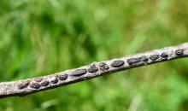  more photos...

HOSTS
Anisogramma anomala is an obligate biotrophic parasite of Corylus spp., which can be grown in culture only with difficulty (Stone et al., 1994). Its native host is Corylus americana, a common understorey shrub of forests in the Eastern USA. It causes the severe stem canker disease Eastern filbert blight on cultivated hazelnut, Corylus avellana. It has also been reported on other Corylus spp.
Host list: Corylus americana, Corylus avellana, Corylus colurna, Corylus heterophylla

GEOGRAPHICAL DISTRIBUTION
Occurring naturally on wild Corylus americana across its wide native range in the Eastern USA and Southern Canada (Barss, 1930), A. anomala spread to Washington in the 1960s (Cameron & Gottwald, 1978), to Oregon in 1986, and from those states to British Columbia (Canada) (Pinkerton et al., 1992). It is now found throughout the Willamette Valley of Oregon where 99% of the hazelnuts grown in the USA are produced.
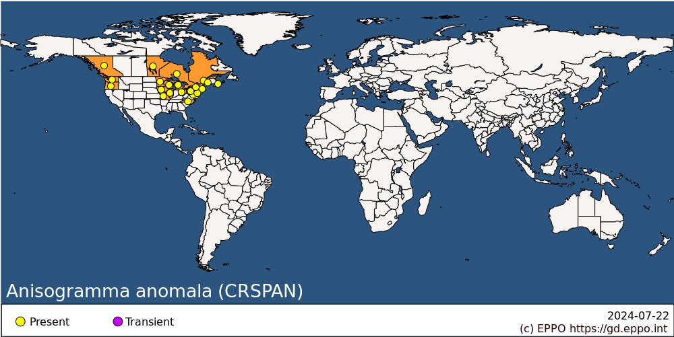
North America: Canada (British Columbia, Manitoba, Nova Scotia, Ontario, Québec), United States of America (Connecticut, Delaware, Illinois, Iowa, Maine, Maryland, Massachusetts, Michigan, Minnesota, Missouri, New Jersey, New York, North Carolina, Ohio, Oregon, Pennsylvania, Washington, Wisconsin)

BIOLOGY
Anisogramma anomala is an obligate biotroph of Corylus spp. Ascospores are the only known spore type; they are discharged from perithecia on diseased branches from autumn to late spring (Pinkerton et al., 1990). Wetting of the stromata causes perithecial ostioles to open. Ascospores are ejected then transported by wind-driven rain and splash droplets within the canopy. Extended periods of rainfall are needed to release spores and infect trees. The ascospores actively infect young vegetative tissue in spring (Gottwald & Cameron, 1980a), after budburst through leaf emergence and shoot elongation (Stone et al., 1992; Johnson et al., 1994). Once established, A. anomala colonizes the cambial tissue with no immediate outward signs or symptoms. Stromata, containing perithecia, develop within cankers 16-18 months after initial infection (a cold period or a dormancy period is required to trigger canker development). Perithecia mature in late summer to early autumn, and although spores can be shed during rain events through the winter dormancy period, infection only occurs in the spring at budbreak. Stromata continue to form at the margins of existing cankers in successive years. Cankers expand at an average rate of 0.3 m per year (Gottwald & Cameron, 1980a). Cankers girdle branches, causing dieback of tree canopies and death of mature trees in 5-15 years. Younger trees may be killed within 4-7 years or earlier as documented in the Eastern USA (Capik & Molnar, 2012). New susceptible shoots may continue to emerge from the roots. Cai et al. (2013) documented the exceptionally large genome of A. anomala and Muehlbauer et al. (2019) documented significant genetic diversity in samples collected across North America.

DETECTION AND IDENTIFICATION

Symptoms
The first signs appear 16-18 months after infection, in late spring to early summer, exhibited as slightly sunken cankers with young stromata swelling under the bark of stems. Some flagging of leaves may also be observed at this time. By late summer into early autumn, characteristic, elliptical dark stromata (2-3 mm long × 1-2 mm high) erupt through the bark. Stromata are fully formed by late autumn. Cankers are perennial and expand along the length of the branch and then laterally each year. They may coalesce when growing. Cankers continue expanding adding additional rows of stromata annually until the host stem eventually dies from disruption of its vascular tissue. Once enough stems die, the host tree dies. This process can take multiple years depending on disease pressure, climate, and the host’s response.

Morphology
About 200 stromata are formed per canker, with 40-60 perithecia per stroma (Gottwald & Cameron, 1980b). The perithecia are dispersed and immersed in the stroma, which is outlined by a blackened zone. Ostiolar necks erupt through the outer tissues of the host. Ascomal wall is two-layered. The asci are unitunicate, 8-spored with deliquescent base so that mature asci lie free in the perithecium at maturity. Ascospores are hyaline, bicellular, with two subequal cells (Hanlin, 1990). The morphology of the fungus is described by Gottwald & Cameron (1979).

Detection and inspection methods
Identification is generally based on morphological examination of infected stems exhibiting cankers with characteristic stromata and microscopic examination of extracted ascospores.The morphological characters of this fungus are very specific and confusion with other fungi is not likely. This fungus cannot be cultured from infected tissues without sporulating perithecia and growth in culture is generally limited. Its short-lived hyphal colonies are similar to many other biotrophic fungi (Stone et al., 1994; Cai et al., 2013). A TaqMan real-time PCR test targeting a ribosomal DNA internal transcribed spacer (Molnar et al., 2013) may be performed to confirm the identity of the pathogen.
For more details regarding detection and morphological identification of A. anomala, see EPPO Standard PM 7/90 (EPPO, 2009).

PATHWAYS FOR MOVEMENT
Natural spread is by rain splash and wind-driven rain which is only over relatively short distances. However, the fungus can be spread long distances through infected Corylus spp. plants for planting. The latent period (16-18 months) with no external signs or symptoms enables the possibility of undetected spread though shipping and planting of infected Corylus materials.

PEST SIGNIFICANCE

Economic impact
In the USA, A. anomala originally had little economic importance when it remained confined to the eastern half of the USA on wild Corylus spp. which are highly tolerant. However, it was inadvertently introduced into South-West Washington state in the 1960s (Davison and Davidson, 1973). Nearly all orchards within a 10 km radius of the initial site of introduction were destroyed, and the disease continued to spread to the southwest. Since 1986, it spread to Oregon in the Willamette Valley, where today 99% of commercial hazelnuts in the USA are produced (Mehlenbacher et al., 1994). Today, the disease is widespread in Oregon and has negative impacts on all the production regions of hazelnuts in the USA. After several decades of breeding at Oregon State University in Corvallis, Oregon, USA, new disease resistant cultivars were developed, such as Yamhill, Jefferson, and Dorris, with many additional sources of resistance identified (Mehlenbacher et al., 2023). Orchards of susceptible cultivars, such as Barcelona, are in the process of being replaced. New resistant cultivars have allowed for a significant increase in tree planting and production in Oregon after the orchard loss due to introduction of A. anomala.

Control
Eradication was originally attempted in Washington and Oregon but was not feasible as volunteer hazelnut plants in adjacent woodlands and roadsides provided an unmanageable reservoir of inoculum. Today, management of Eastern filbert blight in Oregon, USA, primarily involves planting resistant cultivars. When managing orchards containing susceptible cultivars, recommendations include the removal of cankered limbs by scouting in winter then pruning, along with application of fungicides. Four applications of fungicides starting at bud swell through budbreak covering an 8-week period are currently recommended. Specific fungicide recommendations can be found in Pscheidt (2023).

Phytosanitary risk
The fungus is only found in North America at the moment but, given its biology, it could be expected to survive, find suitable conditions for infection and be very damaging to wild populations and commercial plantations of Corylus avellana in the EPPO region. Studies have shown that most C. avellana are highly susceptible although rare resistant and tolerant individuals exist across cultivated and native populations (Mehlenbacher et al., 2023; Capik and Molnar, 2012; Molnar et al., 2018).

PHYTOSANITARY MEASURES
Anisogramma anomala can be introduced with planting material of Corylus spp. harbouring latent infections. In the case of the USA, spread of the disease to the West is thought to have been due to the importation of infected Corylus avellana nursery stock or of wild C. americana seedlings from the eastern regions. Planting material of Corylus spp. should be imported only from areas free from A. anomala.

REFERENCES
Barss HP (1930) Eastern filbert blight. California Agriculture Department Bulletin 19, 489-490.
Cameron HR & Gottwald TR (1978) Progress report on Eastern filbert blight. Proceedings of the Nut Growers Society of Oregon, Washington and British Columbia 63, 522-523.
Cai G, Leadbetter CW, Muehlbauer MF, Molnar TJ & Hillman BI (2013) Genome-wide microsatellite identification in the fungus Anisogramma anomala using Illumina sequencing and genome assembly. PLoS One 8(11), e82408. https://doi.org/10.1371/journal.pone.0082408
Capik JM & Molnar TJ (2012) Assessment of host (Corylus sp.) resistance to Eastern filbert blight in New Jersey. Journal of the American Society for Horticultural Science 137(3), 157-172.
Davison AD & Davidson RM Jr (1973) Apioporthe and Monochaetia cankers reported in Western Washington. Plant Disease Reporter 57, 522-523.
EPPO (2009) EPPO Standards. Diagnostics. PM 7/90 (1) Anisogramma anomala. EPPO Bulletin 39(1), 293-297.
Gottwald TR & Cameron HR (1979) Morphology and life history of Anisogramma anomala. Mycologia 71, 1107-1126.
Gottwald TR & Cameron HR (1980a) Infection site, infection period and latent period of canker caused by Anisogramma anomala in European filbert. Phytopathology 70, 1083-1087.
Gottwald TR & Cameron HR (1980b) Disease increase and the dynamics of spread of cankers caused by Anisogramma anomala in European filbert in the Pacific Northwest. Phytopathology 70, 1087-1092.
Hanlin RT (1990) Illustrated genera of Ascomycetes, pp. 136-137. APS Press, St. Paul, Minnesota, USA.
Johnson KB, Pinkerton JN, Gaudreault SM & Stone JK (1994) Infection of European hazelnut by Anisogramma anomala: site of infection and effect of host developmental stage. Phytopathology 84, 1465-1470.
Mehlenbacher SA, Pinkerton JN, Johnson KB & Pscheidt JW (1994) Eastern filbert blight in Oregon. Acta Horticulturae 351, 551-557.
Mehlenbacher SA, Heilsnis BJ, Mooneyham RT & Snelling JW (2023) Breeding hazelnuts resistant to Eastern filbert blight. Acta Horticulturae 1362, 557-562. https://doi.org/10.17660/ActaHortic.2023.1362.75
Molnar TJ, Walsh E, Capik JM, Sathuvalli V, Mehlenbacher SA, Rossman AY & Zhang N (2013) A real-time PCR assay for early detection of Eastern filbert blight. Plant Disease 97, 813-818.
Molnar TJ, Lombardoni JJ, Muehlbauer MF, Honig JA, Mehlenbacher SA & Capik JM (2018) Progress breeding for resistance to eastern filbert blight in the eastern United States. Acta Horticulturae 1226, 79-85. https://doi.org/10.17660/ActaHortic.2018.1226.11
Muehlbauer MF, Tobia J, Honig JA, Zhang N, Hillman BI, Gold KM, & Molnar TJ (2019) Population differentiation within Anisogramma anomala in North America. Phytopathology 109, 1074–1082. https://doi.org/10.1094/PHYTO-06-18-0209-R
Pscheidt J (2023) Hazelnut (Corylus avellana) - Eastern Filbert Blight. In: Pscheidt JW & Ocamb CM (eds) Pacific Northwest Plant Disease Management Handbook. Corvallis, OR: Oregon State University. https://pnwhandbooks.org/plantdisease/host-disease/hazelnut-corylus-avellana-eastern-filbert-blight (accessed 31 May 2023).
Pinkerton JN, Johnson KB, Stone JK & Pscheidt JW (1990) Ascospore discharge of Anisogramma anomala under field and controlled conditions. Phytopathology 80, 1031.
Pinkerton JN, Johnson KB, Theiling KM & Griesbach JA (1992) Distribution and characterization of the Eastern filbert blight epidemic in Western Oregon. Plant Disease 76, 1179-1182.
Stone JK, Johnson KB, Pinkerton JN & Pscheidt JW (1992) Natural infection period and susceptibility of vegetative seedlings of European hazelnut to Anisogramma anomala. Plant Disease 76, 348-352.
Stone JK, Pinkerton JN & Johnson KB (1994) Axenic culture of Anisogramma anomala: evidence for self-inhibition of ascospore germination and colony growth. Mycologia 86, 674-683.

ACKNOWLEDGEMENTS
This datasheet was extensively revised in 2023 by Thomas Molnar, Department of Plant Biology, Rutgers University, New Brunswick, New Jersey, USA. His contribution is gratefully acknowledged.

How to cite this datasheet?
EPPO (2024) Anisogramma anomala. EPPO datasheets on pests recommended for regulation. Available online. https://gd.eppo.int

Datasheet history
This datasheet was first published in 1997 in the second edition of 'Quarantine Pests for Europe', and revised in 2023. It is now maintained in an electronic format in the EPPO Global Database. The sections on 'Identity', ‘Hosts’, and 'Geographical distribution' are automatically updated from the database. For other sections, the date of last revision is indicated on the right.
CABI/EPPO (1997) Quarantine Pests for Europe (2nd edition). CABI, Wallingford (GB).

