EPPO Datasheet: Crinivirus lactucaflavi
Last updated: 2023-05-15

IDENTITY
Preferred name: Crinivirus lactucaflavi  Taxonomic position: Viruses and viroids: Riboviria: Orthornavirae: Kitrinoviricota: Alsuviricetes: Martellivirales: Closteroviridae: Crinivirus  Other scientific names: LIYV, Lettuce infectious yellows crinivirus, Lettuce infectious yellows virus  Common names in English: infectious yellows of lettuce  view more common names online...  EPPO Categorization: A1 list  EU Categorization: A1 Quarantine pest (Annex II A)  view more categorizations online...  EPPO Code: LIYV00 | more photos...

Notes on taxonomy and nomenclature
Lettuce infectious yellows virus (LIYV) is the type member of the genus Crinivirus in the family Closteroviridae. Viruses in this genus are transmitted by specific whitefly vectors, have filamentous, rod-shaped virions and two positive-sense genomic RNAs (Klaassen et al., 1995).

HOSTS
LIYV has a wide host range (at least 45 species in 15 families). The most economically significant hosts in North America are sugarbeets (Beta vulgaris), lettuces (Lactuca sativa), marrows (Cucurbita pepo) and melons (Cucumis melo). Other natural hosts include carrots (Daucus carota) and the cucurbits Cucurbita foetidissima, C. maxima, C. moschata and watermelons (Citrullus lanatus) (Duffus et al., 1986; Halliwell and Johnson, 1992). LIYV also infects various weeds, including Ipomoea spp., Lactuca canadensis, and Malva parviflora. In addition, Chenopodium capitatum and Nicotiana benthamiana are excellent experimental hosts.
Host list: Beta vulgaris, Chenopodiastrum murale, Chenopodium album, Citrullus lanatus, Cucumis melo, Cucurbita foetidissima, Cucurbita maxima, Cucurbita moschata, Cucurbita pepo, Daucus carota, Ipomoea purpurea, Lactuca canadensis, Lactuca sativa, Lactuca serriola, Malva parviflora, Portulaca oleracea, Rumex crispus, Sonchus oleraceus, Taraxacum officinale

GEOGRAPHICAL DISTRIBUTION
LIYV emerged in the South-West USA and nearby regions of Mexico in the early 1980s coinciding with the introduction and massive proliferation of very large populations of B. tabaci (Duffus et al., 1996). The original B. tabaci, present at that time, was referred to as biotype A, now called the New World cryptic species, and is a very efficient vector of LIYV. B. tabaci New World populations and LIYV remained limited to the South-West USA for a few years. Subsequent build up of large populations of other B. tabaci cryptic species, MEAM-1 (biotype B) and Med (biotype Q), which are inefficient vectors of LIYV, led to displacement of the B. tabaci New World vector and disappearance of LIYV. The map below shows the LIYV distribution in the mid 1980s and early 1990s, however LIYV has not been reported from North America since about the mid 1990s.
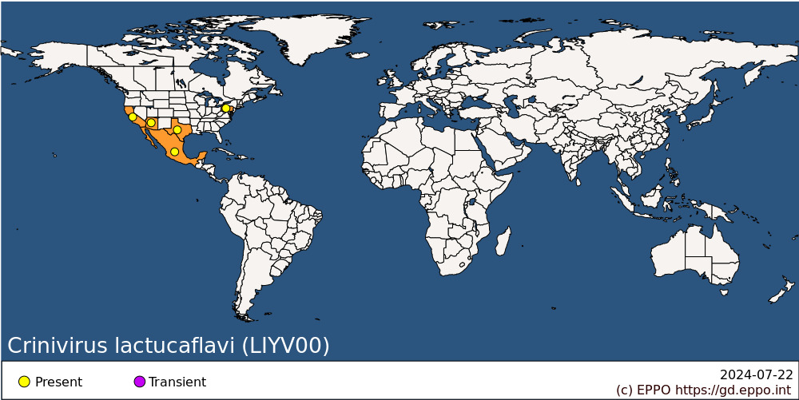
North America: Mexico, United States of America (Arizona, California, Pennsylvania, Texas)

BIOLOGY
LIYV is transmitted in a semi-persistent manner by Bemisia tabaci New World. B. tabaci is recognized as one of the worlds’ worst invasive species (Global Invasive Species Database, http://www.issg.org/database) and is composed of many cryptic species, formerly called biotypes (Dinsdale et al., 2010). B. tabaci New World (biotype A), is the efficient whitefly vector associated with LIYV (Duffus et al., 1986). Detailed studies have shown that other B. tabaci cryptic species do not efficiently transmit LIYV (Chen et al., 2021). LIYV is retained by viruliferous whiteflies for several days (Duffus et al., 1986). Susceptible vegetable crops normally become infected by the migration of high numbers of viruliferous B. tabaci from other cultivated hosts. LIYV is not transmitted to plants by mechanical inoculation.

DETECTION AND IDENTIFICATION

Symptoms
Infected plants show severe yellowing and/or reddening of the leaves, together with stunting, rolling, vein clearing and brittleness (Brown & Nelson, 1986). Older leaves show distinct interveinal yellowing while veins remain green.

Morphology
Virions are flexuous filaments, ~ 800-900 nm long and ~13-15 nm wide (Tian et al., 1999). Hoefert et al. (1988) and Pinto et al. (1988) describe the ultrastructural effects in LIYV-infected lettuce, especially the unique formation of conical deposits on the plasmalemma of phloem parenchyma cells. These structures are composed of a LIYV-encoded protein and are involved in LIYV spread within infected plants (Qiao et al., 2018).

Detection and inspection methods
Preparations of LIYV virions are immunogenic and the virus can be detected by ELISA and immunoblot analysis (Duffus et al., 1986; Tian et al., 1999). More recent diagnostic methods are nucleic acid-based, particularly RT-PCR targeting the conserved HSP-70h coding region (Tian et al., 1996). Recommended indicator plants for whitefly transmission of LIYV are: Beta vulgaris, Brassica pekinensis, Chenopodium capitatum, Citrullus lanatus, Cucumis melo, Cucumis sativus, Lactuca sativa, Malva parviflora, Nicotiana clevelandii and Trifolium subterraneum, all of which show the symptoms noted above. In addition, cloned infectious cDNAs can be experimentally transmitted by agroinoculation (inoculation of recombinant LIYV plasmids via Agrobacterium tumefaciens) to Nicotiana benthamiana plants (Wang et al., 2009).

PATHWAYS FOR MOVEMENT
LIYV spreads naturally only by its vector Bemisia tabaci New World which can spread it within and between fields (and presumably glasshouses) in infested areas. In international trade, it is very unlikely to be carried by plants of its main cultivated hosts, since these are short-lived vegetable crops not normally moved. Young seedlings for transplanting might constitute a pathway, but would still be unlikely to move in intercontinental trade. Therefore, the main risk of movement is in B. tabaci New World on other host plants (e.g. ornamentals), given the fact that the vector moves readily from one host to another, and that the virus can persist in the vector for several weeks after acquisition.

PEST SIGNIFICANCE

Economic impact
LIYV has caused severe losses on marrow, melon and related cucurbit crops in California (USA) (Duffus & Flock, 1982; Nameth et al., 1985). Yield of lettuce may be reduced up to 75% by infection. The disease has also been found causing serious losses in hydroponically grown lettuces in North-Eastern USA (Brown & Stanghellini, 1988). It is one of several criniviruses which have become very important since the spread of Bemisia tabaci throughout the world. However, largely due to displacement of B. tabaci New World (efficient LIYV vector) by other, non-vector B. tabaci cryptic species, LIYV has not caused economic losses in recent years.

Control
Control mainly aims at eliminating or excluding the vector Bemisia tabaci, and also weed hosts which may act as reservoirs for both LIYV and B. tabaci (Wood, 1988). Protective row covers of spun-bonded polyester over seedlings as a floating cover showed some effectiveness (Natwick & Durazo, 1985). Lettuce cultivars differ in susceptibility to LIYV (McCreight et al., 1986), and resistance or tolerance has also been studied in melons and sugarbeet, but no effective resistance is known.

Phytosanitary risk
LIYV could present a threat to the cultivation of lettuces and cucurbits (especially courgettes and melons), in the open in Southern Europe or under glass in Northern Europe, wherever B. tabaci New World occurs. However, its apparent disappearance from agricultural systems in North America due to the displacement of B. tabaci New World by non-efficient vectors has lowered the risk for the EPPO region.

PHYTOSANITARY MEASURES
Host plants of Bemisia tabaci from areas where LIYV occurs should come from a place of production free from LIYV and B. tabaci New World during the last growing season.

REFERENCES
Brown JK & Nelson MR (1986) Whitefly-borne viruses of melons and lettuce in Arizona. Phytopathology 76, 236-239.
Brown JK & Stanghellini ME (1988) Lettuce infectious yellows virus in hydroponically grown lettuce in Pennsylvania. Plant Disease 72, 453.
Chen AYS, Zhou JS, Liu J-X & Ng JCK (2021) Nuances of whitefly vector-crinivirus interactions revealed in the foregut retention and transmission of lettuce chlorosis virus by two Bemisia tabaci cryptic species. Viruses 13, 1578. https://doi.org/10.3390/v13081578
Dinsdale A, Cook L, Riginos C, Buckley YM & De Barro P (2010) Refined global analysis of Bemisia tabaci (Hemiptera: Sternorrhyncha: Aleyrodoidea: Aleyrodidae) mitochondrial cytochrome oxidase 1 to identify species level genetic boundaries. Annals of the Entomological Society of America 103, 196-208.
Duffus JE & Flock RA (1982) Whitefly-transmitted disease complex of the desert southwest. California Agriculture 36, 4-6.
Duffus JE, Larsen RC & Liu HY (1986) Lettuce infectious yellows virus - a new type of whitefly-transmitted virus. Phytopathology 76, 97-100.
Halliwell RS & Johnson JD (1992) Lettuce infectious yellows virus infecting watermelon, cantaloupe, honey dew melon, squash, and cushaw in Texas. Plant Disease 76, 643.
Hoefert LL, Pinto RL & Fail GL (1988) Ultrastructural effects of lettuce infectious yellows virus in Lactuca sativa. Journal of Ultrastructure and Molecular Structure Research 98, 243-253.
Klaassen VA., Boeshore ML, Koonin EV, Tian T & Falk BW (1995) Genome structure and phylogenetic analysis of Lettuce infectious yellows virus, a whitefly-transmitted bipartite Closterovirus. Virology 208, 99-110.
McCreight JD, Kishaba AN & Mayberry KS (1986) Lettuce infectious yellows tolerance in lettuce. Journal of the American Society for Horticultural Science 111, 788-792.
Nameth ST, Laemmlen FF & Dodds JA (1985) Viruses cause heavy melon losses in desert valleys. California Agriculture 39, 28-29.
Natwick ET & Durazo A (1985) Polyester covers protect vegetables from whiteflies and virus diseases. California Agriculture 39, 21-22.
Pinto RL, Hoefert LL & Fail GL (1988) Plasmalemma deposits in tissues infected with lettuce infectious yellows virus. Journal of Ultrastructure and Molecular Structure Research 100, 245-254.
Qiao W, Medina V, Kuo Y-W & Falk BW (2018) A distinct, non-virion plant virus movement protein encoded by a crinivirus essential for systemic infection. mBio 9, e02230-18. https://doi.org/10.1128/mBio.02230-18
Tian T, Klaassen VA, Soong J, Wisler G, Duffus JE & Falk BW (1996) Generation of cDNAs specific to Lettuce infectious yellows closterovirus and other whitefly-transmitted closteroviruses by RT-PCR and degenerate nucleotide primers corresponding to the closterovirus gene encoding the heat shock protein homolog. Phytopathology 86, 1167-1173.
Tian T, Rubio L, Yeh H-Y, Crawford B & Falk BW (1999) Lettuce infectious yellows virus: in vitro acquisition analysis using partially purified virions and the whitefly, Bemisia tabaci. Journal of General Virology 80, 1111-1117.
Wang J, Turina M, Stewart LR, Lindbo JA & Falk BW (2009) Agroinoculation of the crinivirus, Lettuce infectious yellows virus, for systemic plant infection. Virology 392, 131-136.
Wood M (1988) Scientists take aim on lettuce menaces. Agricultural Research, USA 36, 10-12.

ACKNOWLEDGEMENTS
This datasheet was extensively revised in 2023 by Bryce Falk, University of California, Davis, CA, USA. His valuable contribution is gratefully acknowledged.

How to cite this datasheet?
EPPO (2024) Crinivirus lactucaflavi. EPPO datasheets on pests recommended for regulation. Available online. https://gd.eppo.int

Datasheet history
This datasheet was first published in 1997 in the second edition of 'Quarantine Pests for Europe', and revised in 2023. It is now maintained in an electronic format in the EPPO Global Database. The sections on 'Identity', ‘Hosts’, and 'Geographical distribution' are automatically updated from the database. For other sections, the date of last revision is indicated on the right.
CABI/EPPO (1997) Quarantine Pests for Europe (2nd edition). CABI, Wallingford (GB).

