EPPO Datasheet: Mycodiella laricis-leptolepidis
Last updated: 2023-10-26

IDENTITY
Preferred name: Mycodiella laricis-leptolepidis  Authority: (Ito, Sato & Ota) Crous  Taxonomic position: Fungi: Ascomycota: Pezizomycotina: Dothideomycetes: Dothideomycetidae: Mycosphaerellales: Mycosphaerellaceae  Other scientific names: Mycosphaerella larici-leptolepis Ito, Sato & Ota, Mycosphaerella laricis-leptolepidis Ito, Sato & Ota, Phoma yano-kubotae Kitajima  Common names in English: needle cast of Japanese larch  view more common names online...  EPPO Categorization: A1 list  EU Categorization: A1 Quarantine pest (Annex II A)  view more categorizations online...  EPPO Code: MYCOLL | 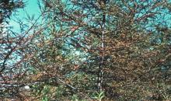  more photos...

Notes on taxonomy and nomenclature
The anamorph of Mycodiella laricis-leptolepidis was according to Ito et al. (1957) first described by Kitajima in 1931 as Phoma yano-kobutae. Phyllosticta laricis, as described by Sawada (1950), is thought to be the same fungus as Phoma yano-kobutae (Ito et al., 1957), however, the description by Kitajima from 1931 could not be found, thus a thorough comparison could not be made.

HOSTS
The principal hosts are Larix decidua, L. gmelinii var. japonica, L. gmelinii var. olgensis and L. kaempferi (synonym: L. leptolepis); the last species is less susceptible. Artificial inoculation to other conifers has been unsuccessful (EFSA et al., 2018; Imazeki & Ito, 1963; Ito et al., 1957).
Larix decidua is widely distributed in Europe at various elevations (e.g. in the Alps and also in the Polish plains; Matras & Pâques, 2008). Larix kaempferi is also planted in the EPPO region (Wu et al., 2020).
Host list: Larix decidua, Larix gmelinii var. japonica, Larix gmelinii var. olgensis, Larix gmelinii, Larix kaempferi

GEOGRAPHICAL DISTRIBUTION
First descriptions of this fungal tree disease were from Japan, and M. laricis-leptolepidis is also considered native to Japan (Kobayashi, 1980). However, there is no evidence to support this claim, and it is unclear if M. laricis-leptolepidis really originates from Japan or if it was introduced from another country. Several tree species from other Asian countries as well as further afield were introduced to Japan for forestry in the late 19th and early 20th century (Imazeki, 1963).
The disease also occurs in the provinces Gansu, Hebei, Heilonjiang, Jilin, Liaoning, Neimenggu, Shaanxi and Shandong of China and in the Democratic People’s Republic of Korea and the Republic of Korea. Details on distribution and pathogenicity of M. laricis-leptolepidis in these countries is limited or difficult to obtain.
No records of the disease are known from the European Union (Anon., 2019), the United Kingdom (Fera, 2019), or any other part of the EPPO region.
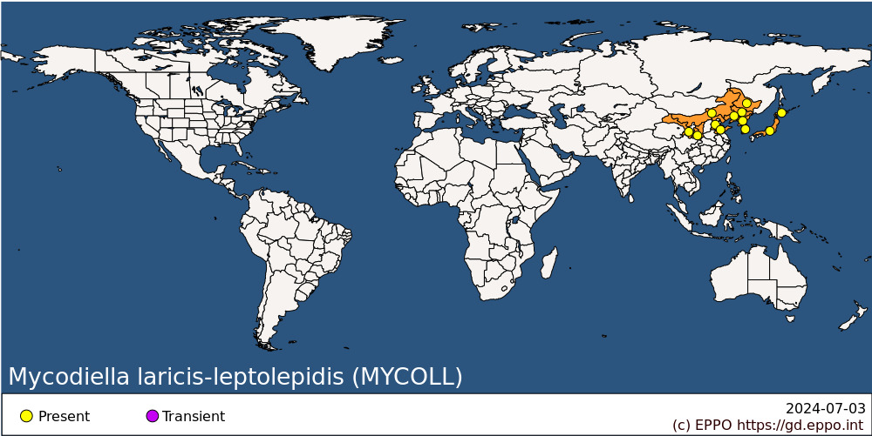
Asia: China (Gansu, Hebei, Heilongjiang, Jilin, Liaoning, Neimenggu, Shaanxi, Shandong), Japan (Hokkaido, Honshu), Korea Dem. People's Republic, Korea, Republic

BIOLOGY
The primary source of inoculum is ascospores. Black pseudothecia develop singly or in groups on fallen needles in contact with the soil during the autumn and winter. Mature ascospores are released only at 100% relative humidity, from late May to mid-June onwards; exceptionally, from mid-May to late August (Pyun and La, 1970). Spore discharge continues for 70 days at 5-10°C but lasts about 13 days at 25°C. The ascospores are carried in air currents and infect the current season's needles. Peak infection occurs in late May to mid-June, with no infection in September. There is an incubation period of 1-2 months (Ito et al., 1957).
Black spermogonia are produced on needles throughout the summer, from July onwards, while the needles are still attached to the tree. The small spermatia are not suited to wind dissemination and do not germinate readily - they play no part in transmission of the disease (Ito et al., 1957).
In general, the disease is more severe on acid soils (e.g. volcanic soils), with lower amounts of potassium or exchangeable calcium (Kobayashi, 1980), or those having a higher coefficient of phosphate absorption and, also, on those soils in which the layer of the A₀ horizon which consists mainly of Larix needles, exceeds 2.5 cm (EFSA, 2018).
For additional information, see Ito et al. (1957), Peace (1962), Anon. (1965), Pyun & La (1970).

DETECTION AND IDENTIFICATION

Symptoms
In early July, scattered brown spots (usually 5-7 but occasionally up to 20 per needle), surrounded by a faint chlorotic halo, appear on needles of the crown (Ito et al., 1957). In most cases the needles of the upper branches are less infected than those of the lower ones (Ito et al., 1957; Pyun and La, 1970). Lesions gradually coalesce, attaining a width of 1 mm or more and cause the needles to go brown and the tree to have a scorched appearance. This coloration is particularly marked in summer and autumn (Ito et al., 1957). Before the needles are cast, black pustules, spermogonia, appear on the upper surface of the dead area. Needle cast results in trees with thinning of all or portions of their crowns with the remaining needles confined to tufts at the end of the branches. Needles from susceptible trees have less chlorophyll, less N, P, K, and more Ca and Si than resistant ones. Nitrogen content falls in the autumn in needles from resistant trees but increases in infected needles in susceptible trees. Repeated defoliation results in a decrease in growth increment and death of shoots and twigs. In general, trees in plantations are most severely affected but seedlings and saplings may also be attacked. Trees in mixed hardwood stands are usually less affected (Kobayashi, 1980).
For additional information, see Ito et al. (1957), Peace (1962), Anon. (1965), Pyun & La (1970).

Morphology
Spermogonia thick-walled and brown, 83-165 x 75-143 µm. Spermatia hyaline, rod-shaped, 3-5 x 0.5-1 µm. Pseudothecia occur individually or in groups, partially erumpent, globose, slightly papillate, 88-156 x 84-142 µm. Asci clavate-cylindrical, 49-99 x 7-12 µm, containing eight ascospores. There are no paraphyses. Ascospores hyaline, unequally two-celled, constricted at the septum, 11-18 x 3-5 µm (Ito et al., 1957).

Detection and inspection methods
The description by Ito et al. (1957) can be used for morphological identification. Mycodiella laricis-leptolepidis can also be distinguished from other species in the Mycosphaerellaceae based on DNA sequences. A protocol and reference sequences are available on the EPPO-Q-bank website.

PATHWAYS FOR MOVEMENT
In natural conditions, dissemination is mainly ensured by windborne ascospores. In international trade, M. laricis-leptolepidis can be transported on infected plants for planting and cut branches of Larix spp.

PEST SIGNIFICANCE

Economic impact
Since the early 1950s, this fungus has increased in prevalence and, although disease severity varies widely between forests, it was reported as the most important defoliator of Larix in Japan (Imazeki & Ito, 1963). In Japan, 10- to 20-year-old forest plantations are most severely infected. Compared to healthy trees, heavily infected trees have a growth increment reduction of up to 80% (Kobayashi, 1980). Mycodiella laricis-leptolepidis does not kill the trees, however, the pathogen is still seen as a major risk to larch production sites in Japan (Wada et al., 2022).

Control
There is no recent information available on control measures against M. laricis-leptolepidis. There have been efforts to produce resistant seedlings, and these have been used in plantations (Kobayashi, 1980). Mancozeb in six 2-weekly applications has given some control in South Korea and it was the most effective of the five fungicides tested (Pyun and La, 1970). In Japan, three to four sprays with copper fungicides during June-July proved effective in preventing disease development and the application of calcium cyanamide on the ground proved effective in killing the pathogen in the fallen needles (Kobayashi, 1980).

Phytosanitary risk
In the EPPO region, M. laricis-leptolepidis could be potentially damaging to Larix, wherever present.

PHYTOSANITARY MEASURES
It could be recommended that countries prohibit importation of plants for planting and cut branches of Larix from countries where M. laricis-leptolepidis occurs.

REFERENCES
Anonymous (1965) Working Group on Needle Cast of Larch. Researches on the needle cast of larch. I-X. Bulletin of the Government Forest Experiment Station, Meguro 178, 1-179.
Anonymous (2019) L 319, Establishing uniform conditions for the implementation of Regulation (EU) 2016/2031 of the European Parliament and the Council, as regards protective measures against pests of plants, and repealing Commission Regulation (EC) No 690/2008 and amending Commission Implementing Regulation (EU) 2018/2019, Annex II. Official Journal of the European Union
Fera (2019) UK risk register details for Mycodiella laricis-leptolepidis. UK Plant Health Risk Register (defra.gov.uk; accessed July 2023)
Imazeki R (1963) Mis. In: Internationally dangerous forest tree diseases. US Department of Agriculture Miscellaneous Publication No. 939, pp. 3-5.
Imazeki R & Ito K (1963) Dangerous forest diseases in Japan - needle cast of larch. In: Internationally dangerous forest tree diseases. US Department of Agriculture Miscellaneous Publication No. 939, pp. 47-48.
Ito K, Sato K & Ota N (1957) Studies on the needle cast of Japanese larch. I. Life history of the causal fungus, Mycosphaerella larici-leptolepis. Bulletin of the Government Forest Experiment Station, Meguro 96, 69-88.
Kobayashi T (1980) Important forest diseases and their control measures. Plant Protection in Japan, Agriculture Asia Special Issue No. 11, pp. 299-300.
Matras J & Pâques L (2008) EUFORGEN Technical Guidelines for genetic conservation and use for European Larch (Larix decidua). Bioversity International, Rome, Italy. 6 pages
Peace TR (1962) Pathology of trees and shrubs. Oxford University Press, Oxford, UK.
Pyun BH & La YJ (1970) Studies on the epidemiology and control of larch needle cast disease caused by Mycosphaerella larici-leptolepis. Research Report, Forest Institute of Korea 17, 29-34
Sawada K (1950) Fungi inhabiting on conifers in the Tõhoku district. II. Fungi on various conifers except ‘Sugi’. Bulletin of the Government Forest Experiment Station (Japan) 46, 129.
Wada H, Tokuda S, Onodera K, Uchida Y, Ohno Y, Takiya M, Ebina M & Saito H (2022) Occurrence status of needle cast of larch species sapling in plantation in relation to leaf nutrition balance. Boreal Forest Research 70, 69-72.
Wu C, Shen J, Chen D, Du C, Su n X & Zhang S (2020) Estimating the distribution characters of Larix kaempferi in response to climate change. iForest 13, 499-506. https://doi.org/10.3832/ifor3570-013
CABI and EFSA resources used when preparing this datasheet
CABI Datasheet on Mycodiella laricis-leptolepidis. https://www.cabidigitallibrary.org/doi/10.1079/cabicompendium.35291
EFSA Pest survey card on Mycodiella laricis-leptolepidis. https://doi.org/10.2903/j.efsa.2018.5246

ACKNOWLEDGEMENTS
This datasheet was extensively revised in 2023 by Sietse van der Linde, NIVIP. His valuable contribution is gratefully acknowledged.

How to cite this datasheet?
EPPO (2024) Mycodiella laricis-leptolepidis. EPPO datasheets on pests recommended for regulation. Available online. https://gd.eppo.int

Datasheet history
This datasheet was first published in the EPPO Bulletin in 1978 and revised in the two editions of 'Quarantine Pests for Europe' in 1992 and 1997, as well as in 2023. It is now maintained in an electronic format in the EPPO Global Database. The sections on 'Identity', ‘Hosts’, and 'Geographical distribution' are automatically updated from the database. For other sections, the date of last revision is indicated on the right.
CABI/EPPO (1992/1997) Quarantine Pests for Europe (1st and 2nd edition). CABI, Wallingford (GB).
EPPO (1978) Data sheets on quarantine organisms No. 16. Mycosphaerella larici-leptolepis. EPPO Bulletin 8(2), 3-6. https://onlinelibrary.wiley.com/doi/abs/10.1111/j.1365-2338.1978.tb02760.x

