EPPO Datasheet: Acrobasis pirivorella
Last updated: 2023-04-20

IDENTITY
Preferred name: Acrobasis pirivorella  Authority: (Matsumura)  Taxonomic position: Animalia: Arthropoda: Hexapoda: Insecta: Lepidoptera: Pyralidae  Other scientific names: Acrobasis pyrivorella (Matsumura), Ectomyelois pyrivorella (Matsumura), Eurhodope pyrivorella (Matsumura), Nephopterix pirivorella Matsumura, Nephopteryx pirivorella Matsumura, Numonia pyrivora (Gerasimov), Numonia pyrivorella (Matsumura), Rhodophaea pyrivorella (Matsumura)  Common names in English: pear driller, pear fruit moth, pear moth, pear pyralid  view more common names online...  EPPO Categorization: A2 list  EU Categorization: A1 Quarantine pest (Annex II A)  view more categorizations online...  EPPO Code: NUMOPI | 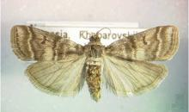  more photos...

Notes on taxonomy and nomenclature
Acrobasis pirivorella was originally described by Matsamura in 1900 (Matsumura, 1900) as Nephopteryx pirivorella from specimens collected in pears in Japan (EFSA., 2018).

HOSTS
Wild and cultivated forms of pears are the main host of A. pirivorella. Shutova (1977) described this pest as restricted to pears, and a literature review, conducted in 2023, did not provide any indication that the moth has been found to attack other fruit trees.
Host list: Pyrus communis, Pyrus ussuriensis

GEOGRAPHICAL DISTRIBUTION
A. pirivorella is indigenous to the temperate zone of Eastern Asia, where it is widely distributed.
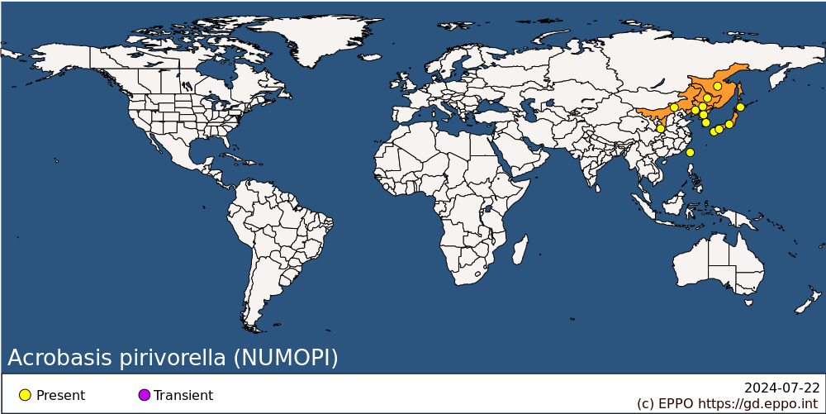
EPPO Region: Russia (Far East)
Asia: China (Heilongjiang, Jilin, Liaoning, Neimenggu, Shaanxi), Japan (Hokkaido, Honshu, Kyushu, Shikoku), Korea Dem. People's Republic, Korea, Republic, Taiwan

BIOLOGY
A. pirivorella overwinters as first-instar larvae (Gibanov & Sanin, 1971), but more commonly as second-instar larvae (Shutova, 1970; Gibanov & Sanin, 1971) in the flower buds of pears in a thin white cocoon. The buds die but do not fall. In spring the larvae move to fresh buds, feed in the developing buds, flowers and fruitlets, eating out the core of the latter. Larvae may move from fruit to fruit. A single larva can infest and destroy two to three buds, one to three primordial flowers and up to three fruits (Shutova, 1977).
Larvae spin a silk attachment to hold the fruit onto the tree and the presence of black shrivelled fruitlets persisting on the trees seems to be a feature of infestation by this species. The larva makes a prominent hole in each fruit near the calyx end with an overhanging lip of silk and excreta. The larvae pupate in the fruit, usually at the end of May and, in Russia (where one generation occurs per year), the first adults emerge by mid-July when the fruit is about the size of a hazel nut. However, most adults will emerge between late July and mid-August (Komarova, 1984).
The moths lay eggs (about 120 per female) both on the new flower buds and on the fruit. Presumably the larvae from the former hibernate, but larvae from eggs on fruit complete development there to produce adults in September. These adults then lay eggs on flower buds and the resulting larvae overwinter. In the cooler areas of Japan (where two generations occur per year) the first flight of adults may not appear until September and the second generation is small. Before the winter, first-generation adults bore into the bud and go into hibernation and those which do not succeed in doing so die (Shutova, 1970). For more information, see Muramatsu (1927), Krylova & Mevzos (1930).

DETECTION AND IDENTIFICATION

Symptoms
Fruits are normally small and turn black with a shrivelled appearance. Furthermore, fruits remain on the tree even until the following year (Shutova, 1977). During summer conspicuous webbing on exit holes and masses of excreta on the exterior of the fruit may indicate an infestation by the pest (Shutova, 1977).

Morphology
Eggs
Length 1 mm, flat and elliptical, yellow when newly laid but darkening to a reddish tint before hatching.
Larva
Rose-pink in the first instar with a black head and a blackish-brown pronotum. Fully developed caterpillars are dark-green dorsally and pale-yellow ventrally with blackish-brown heads and pale-brown legs. They reach a length of 12 mm. Two setae are located on the prespiracule plate of the prothorax (Danilevskii, 1958; Shutova, 1977).
Pupa
Pupae are in general oval, 10-12 mm in length, with a compression towards one end. Their body is brown with darker spiracles. Pupae lie with their heads in the direction of the exit hole in the fruit and when the adult moth emerges the pupal case is left protruding from the fruit.
Adult
A greyish moth with a violet tinge. The wingspan reaches 23 - 30 mm. The forewings have two transverse stripes and between them a crescent-shaped dark apical spot; the hindwings are yellowish-grey. The head, thorax and dorsum are covered with ashen-violet-brown bands. For more information, see Matsumura (1900), Danilevskii (1958), Shutova (1977), Yang-Seop et al. (2017).

Detection and inspection methods
The following chemical compounds (Z)-9-pentadecenyl acetate (Z9-15:OAc) and pentadecenyl acetate (15:OAc) were identified in the pheromone gland of female A. pirivorella (Tabata et al., 2009). Field trials of experimental traps baited with lures containing Z9-15:OAc (300lg) and 15:OAc (21lg) caught more males than traps baited with two virgin females (Tabata et al., 2009). This lure could be used for monitoring and detection purposes (EFSA, 2018).
Visual inspection of fruits, buds and branches could be carried out, the conspicuous webbing on fruits would likely lead to detection if seen, however eggs laid on buds or fruit might be more cryptic and could potentially be missed via visual inspection.

PATHWAYS FOR MOVEMENT
The potential for natural spread of A. pirivorella can be considered as relatively low, with this species being considered a poor flyer natural spread and dispersal is limited (EFSA, 2018). The main means of spread would be international trade of plants for planting and fruits infested with the pest (Shutova, 1977). Cut branches are also a potential pathway.
Fruit imported from countries where A. pirivorella is present is a pathway for this moth into the EPPO region as larvae and pupae of A. pirivorella could be present in fruit at harvest time. As the larvae overwinter in pear flower buds cut branches containing either flower buds or fruit would also be another potential pathway.

PEST SIGNIFICANCE

Economic impact
Economic impact could be high based on the pest’s biology and the severity of damage that has been reported in published literature. In the Far Eastern territories of Russia, A. pirivorella is rated as the most serious pest of cultivated pears, and damage on up to 90% of pear crops have been reported (Shutova, 1970). It is also considered to be of economic importance in Japan (Siezo, 1968).

Control
In Japan, A. pirivorella is controlled by applying fenitrothion, diazinon, cyanophos or methidathion shortly before flowering and two later applications between June and August depending on the developmental stages of the pest (Umeya, 1980). In Russia, the latest insecticidal application is recommended for mid-August (Komarova, 1984). It should be noted that the chemicals mentioned for control in Japan and Russia are not approved for use in the EU.
Biological control has not been thoroughly researched, although Meteorus colon has been reported to parasitize up to 57% of A. pirivorella (Komarova, 1984). Other natural enemies include: Gregopimpla himalayensis (Hymenoptera, Ichneumonidae), Microdus sp. (Hymenoptera Braconidae), Pseudoperichaeta nigrolineata (Diptera, Tachinidae), and Trathala flavoorbitalis (Hymenoptera, Ichneumonidae) (CABI Datasheet, 2022).
Shutova (1977) detailed that in China, fruits growing on trees were individually wrapped in paper to exclude the pest. However, in certain parts of the trees the fruits remained unwrapped and served as bait-fruits which were destroyed after infestation.

Phytosanitary risk
Pome fruits are important crops in the EPPO region. Considering the current range of the pest, it is likely that A. pirivorella could establish, spread and cause damage if it was introduced in the region. It is expected that Integrated Pest Management (IPM) for Pyrus in the EPPO region could limit the impact of A. pirivorella it is likely they would not be fully effective against the pest and would need to be modified to adapt to its biology (e.g. the timing of application of insecticides).

PHYTOSANITARY MEASURES
Fruits of host plants from countries where the pest occurs should be free from the pest. This can be achieved if the fruits come from a pest-free area. Other risk management measures may be relevant (e.g., treatment of the fruit) but an assessment should be made to determine if they are appropriate and feasible.
It should be noted that the import of Pyrus plants for planting is prohibited in many EPPO countries (EFSA, 2018).
Requiring that plants for planting or cut branches of hosts originate from a pest free area is an appropriate phytosanitary measure to reduce the risk of entry.

REFERENCES
Danilevskii AS (1958) [The species of fruit moths (Lepidoptera, Pyralidae, Carposinidae, Tortricidae) injurious to fruit trees in the Far East]. Revue d'Entomologie de l'URSS 37, 282-293.
EFSA (2018) Pest categorisation of Acrobasis pirivorella. EFSA Journal 16(10). https://doi.org/10.2903/j.efsa.2018.5440
EPPO/CABI (1996) Carposina niponensis. In: Quarantine pests for Europe. 2nd edition (Ed. by Smith IM, McNamara DG, Scott PR, Holderness M). CABI, Wallingford, UK.
Gerasimov AM (1926) [Numonia pyrivora sp. n. (Lepidoptera, Phycitini) a pear pest in Primorskii region]. Entomologichnoe Obozrenie 20, 127-135.
Gibanov PK & Sanin YV (1971) [Lepidopteran pests of fruits in Primor'ye Province]. Zaschita Rastenii 16(8), 41-43.
Komarova GF (1984) [The pear pyralid]. Zashchita Rastenii No. 7, p. 36.
Krylova M & Mevzos N (1930) [On the biology of the pear pyralid Numonia pirivorella Mats]. Zashchita Rastenii 6(5-6), 659-662.
Matsumura S (1900) [New Japanese microlepidoptera]. Entomologische Nachrichten, Berlin 26, 193-199.
Muramatsu S (1927) [Notes on the life-histories and habits of four fruit moths in Chosen]. Journal of the Agricultural Experimental Station, Chosen No. 16.
Shiraki T (1952) Catalogue of injurious insects in Japan. Natural Resources Division. G.H.Q. Allied Powers No. 71, 842 pp.
Shutova NN (1970) [The pear moth Numonia pirivorella Mats]. In: Guide to quarantine pests, diseases and weeds (Ed. by Shutova NN). Kolos, Moscow, Russia.
Shutova NN (1977) [The pear pyralid]. Zashchita Rastenii 9, 38.
Siezo NTN (1968) List of important diseases and pests of economic plants in Japan. Japan Plant Protection Society, Tokyo, Japan.
Tabata J, Minamishima M, Sugie H, Fukumoto T, Mochizuki F & Yoshiyasu Y (2009) Sex pheromone components of the pear fruit moth, Acrobasis pyrivorella (Matsumura). Journal of Chemical Ecology 35(2), 243–249.
Umeya K (1980) Major insect pests on deciduous fruit trees. In: Plant Protection in Japan. Agriculture Asia 11 (special issue), 216-223.
Yang-Seop Bae, Munki Paek & Mujie Qi (2017) Insect Fauna of Korea: Arthropoda: Insecta: Lepidoptera: Pyralidae (Phycitinae I) Pyralid Moths II, Volume 16, Number 15, National Institute of Biological Resources, Republic of Korea.

ACKNOWLEDGEMENTS
This datasheet was extensively revised in 2023 by Duncan Allen, Department for Environment Food & Rural Affairs UK. His valuable contribution is gratefully acknowledged.

How to cite this datasheet?
EPPO (2024) Acrobasis pirivorella. EPPO datasheets on pests recommended for regulation. Available online. https://gd.eppo.int

Datasheet history
This datasheet was first published in 1997 in the second edition of 'Quarantine Pests for Europe', and revised in 2023. It is now maintained in an electronic format in the EPPO Global Database. The sections on 'Identity', ‘Hosts’, and 'Geographical distribution' are automatically updated from the database. For other sections, the date of last revision is indicated on the right.
CABI/EPPO (1997) Quarantine Pests for Europe (2nd edition). CABI, Wallingford (GB).

