EPPO Datasheet: Peach yellows phytoplasma
Last updated: 2022-07-05

IDENTITY
Preferred name: Peach yellows phytoplasma
Taxonomic position: Bacteria: Tenericutes: Mollicutes: Acholeplasmatales: Acholeplasmataceae
Other scientific names: Little peach phytoplasma, Peach red suture phytoplasma
Common names in English: little peach, peach red suture, peach yellows
view more common names online...
EPPO Categorization: A1 list
view more categorizations online...
EPPO Code: PHYP29

Notes on taxonomy and nomenclature
Work by Davis et al. (2013), employing sequence and computer-simulated RFLP analyses of 16S rDNA, has shown that peach yellows (also called little peach) phytoplasma is to be regarded as the X-disease agent ‘Candidatus Phytoplasma pruni’, a member of the X-disease phytoplasma group or 16SrIII group, subgroup 16SrIII-A. Phytoplasmas associated with peach rosette and peach red suture diseases are also regarded as ‘Candidatus Phytoplasma pruni’ (Davis et al., 2013).

HOSTS
Peach (Prunus persica) is the principal host of peach yellows phytoplasma. Almond (P. dulcis), apricot (P. armeniaca) and Japanese plum (P. salicina) are also infected. All Prunus spp. which have been experimentally graft-inoculated proved to be susceptible. Peach yellows phytoplasma is symptomless in some cultivars of P. salicina such as Abundance, Chalco and Chabot. The phytoplasma can also be artificially transmitted to herbaceous hosts.
Host list: Prunus armeniaca, Prunus dulcis, Prunus persica, Prunus salicina, Prunus

GEOGRAPHICAL DISTRIBUTION
Peach yellows was first observed in Pennsylvania in 1791 (Kunkel, 1936a). The disease spread gradually northward, through the New England states and into Canada and southward into Delaware, Maryland, Virginia, West Virginia, and North Carolina. Peach yellows has not been found in the far western or southern states or outside USA and Canada. European diseases called peach yellows are either caused by other phytoplasmas or have unknown etiologies (Marcone et al., 2014). Epidemic outbreaks in the United States during the 19th and early 20th centuries caused significant tree losses (Kirkpatrick, 1995). Recently, disease incidence has been low (Scott and Zimmerman, 2001; Kirkpatrick et al., 2011).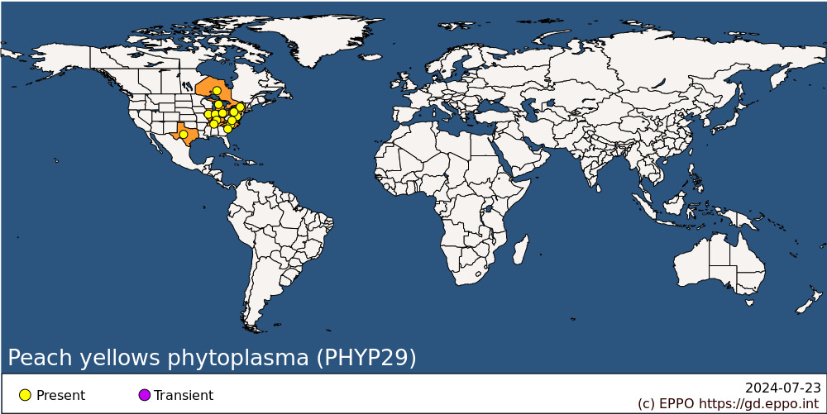
North America: Canada (Ontario), United States of America (Illinois, Indiana, Kentucky, Maryland, Michigan, New York, North Carolina, Ohio, Pennsylvania, South Carolina, Tennessee, Texas, Virginia)

BIOLOGY
The peach yellows phytoplasma is transmitted by grafting and by the plum leafhopper Macropsis trimaculata (Hemiptera: Cicadellidae). It has an incubation period of 1-3 years in trees in orchards but less than 60 days under glasshouse conditions. In the vector, the mean latent period is 16 days (Pine & Gilmer, 1976; Weintraub & Beanland, 2006). Symptoms of peach red suture disease are similar to those of peach yellows. However, attempts to transmit peach red suture disease with the leafhopper M. trimaculata have failed.

DETECTION AND IDENTIFICATION

Symptoms
Leaf buds on diseased peach trees, even those that should normally remain dormant, develop prematurely. Leaves produced from these buds are narrower and smaller than normal leaves, and as the season progresses, they become chlorotic and often develop red spots. Affected trees produce slender, branched, willowy shoots that grow upright from the main limbs, thus giving the tree a bushy appearance. Leaves borne on the abnormal shoots are dwarfed, severely chlorotic with the margins rolled upward and drop prematurely. As the disease progresses, diseased limbs dieback and the trees succumb one to five years later. Fruits produced on diseased limbs ripen two to three weeks earlier than healthy fruits. They are of normal size but of low quality, usually with a bitter taste. In red-skinned cultivars, the fruit surface shows highly pigmented spots with red streaks in the flesh and a pronounced red colour around the pit (Dunez, 1981; Kirkpatrick, 1995).

Morphology
Electron microscope studies have shown the presence of typical phytoplasma bodies in sieve tube elements of peach trees exhibiting peach yellows symptoms, and in periwinkle (Catharanthus roseus) plants following dodder transmission from peach (Jones et al., 1974a, b). The bodies were often present in very large numbers, they were surrounded by a unit membrane and contained in their cytoplasm, dispersed strands resembling DNA and ribosome granules. They were morphologically indistinguishable from those associated with other phytoplasmal diseases.

Detection and inspection methods
The peach yellows phytoplasma can be tested on peach seedlings (cv. Elberta or GF305) in the field, but it takes 4 years for results to be certain. It can also be tested on the same indicators in the glasshouse, symptoms appearing up to 3 months after inoculation. However, for reliable diagnosis, the identity of the infecting phytoplasma should be determined by molecular technologies such as PCR-based methods. Universal phytoplasma primers as well as X-disease group-specific primers have been designed, directed to ribosomal or non-ribosomal DNA sequences. Primers amplifying rDNA sequences are the most extensively used (Hadidi et al., 2011; Bertaccini et al., 2019; Martini et al., 2019). The sensitivity of detection can be increased by nested PCR.

PATHWAYS FOR MOVEMENT
The peach yellows phytoplasma is spread locally by the insect vector whereas the use of infected plant material is responsible for long-distance movement of the pathogen. Abiotic factors are not involved in natural spread of the pathogen.

PEST SIGNIFICANCE

Economic impact
Peach yellows was responsible for serious losses in the USA in the 19th century, when it was the object of classic research by Erwin Smith (who failed, not surprisingly, to establish the nature of the agent) and of some of the first legislative measures against a plant disease (Michigan Yellows Law of 1875) (Ainsworth, 1981). Severe outbreaks continued into the early 20th century but in recent decades the disease has been seen only rarely (Kirkpatrick et al., 2011). Pine & Gilmer (1976) reported that peach yellows disease tended to follow a cyclical pattern in large peach-growing areas. More recently, peach yellows disease affects only a few trees within an orchard in the South-Eastern United States. Symptomatic trees do not emerge from dormancy, and this results in the loss of a few trees with relatively little economic impact. The greatest economic impact in the South-Eastern United States is that budwood from sources on the east coast cannot be exported to states on the west coast because of embargo based on the possible latent presence of this disease and its graft transmissibility (Kirkpatrick et al., 2011).

Control
Infected trees should be destroyed and the insect vector Macropsis trimaculata should be controlled. Healthy planting material should be used for establishing new orchards. In this respect, peach yellows was one of the first 'virus-like' diseases to be treated using thermotherapy. The pathogen is eliminated from dormant trees and buds by hot-water treatment at 50°C for 10 and 3-4 min, respectively (Kunkel, 1936b).

Phytosanitary risk
In the EPPO region, peach, the main host, has the greatest economic importance among all Prunus spp. There are probably susceptible European cultivars and, in any case, American cultivars are frequently introduced. Though the American vector does not occur in Europe, local insects might act as vectors. Healthy planting material of Prunus is recommended, and nuclear stocks should be screened at regular intervals using highly sensitive PCR-based tests. However, this pest is undoubtedly less important than peach X-disease phytoplasma (EPPO/CABI, 1996).

PHYTOSANITARY MEASURES
Prunus planting material should come from a field inspected during the growing season and, particularly for material from infested countries, the material should be subject to an official certification scheme, with particular emphasis on preventing infection of healthy material by the insect vector. The EPPO certification scheme for fruit trees (EPPO, 2001a, b), though intended to be used primarily within the EPPO region, provides a suitable model.

REFERENCES
Ainsworth GC (1981) An introduction to the history of plant pathology. Cambridge University Press, Cambridge, UK.
Bertaccini A, Paltrinieri S & Contaldo N (2019) Standard detection protocol: PCR and RFLP analyses based on 16S rRNA gene. In Phytoplasmas: Methods and Protocols, Methods in Molecular Biology (eds Musetti R & Pagliari L), volume 1875, pp. 83-95. Springer Science+Business Media, LLC, New York, USA.
Davis RE, Zhao Y, Dally EL, Lee I-M, Jomantiene R & Douglas SM (2013) ‘Candidatus Phytoplasma pruni’, a novel taxon associated with X-disease of stone fruits, Prunus spp.: multilocus characterization based on 16S rRNA, secY, and ribosomal protein genes. International Journal of Systematic and Evolutionary Microbiology 63, 766-776.
Dunez J (1981) Exotic virus and virus-like diseases of fruit trees. EPPO Bulletin 11, 251-258.
EPPO (2001a) PM 4/29 Certification scheme for cherry. EPPO Bulletin 31(4), 447-461.
EPPO (2001b) PM 4/30 Certification scheme for almond, apricot, peach and plum. EPPO Bulletin 31(4), 463-478.
EPPO/CABI (1996) Peach X-disease phytoplasma. In: Quarantine pests for Europe. 2nd edition (Ed. by Smith IM, McNamara DG, Scott PR, Holderness M). CABI, Wallingford, UK.
Hadidi A, Olmos A, Pasquini G, Barba M, Martin RR & Shamloul AM (2011) Polymerase chain reaction for detection of systemic plant pathogens. In: Virus and Virus-Like Diseases of Pome and Stone Fruits (eds Hadidi A, Barba M, Candresse T & Jelkmann W), pp. 341-359. APS Press, St. Paul, MN, USA.
Jones AL, Hooper GR, Rosenberger DA & Chevalier J (1974a) Mycoplasma-like bodies associated with peach and periwinkle exhibiting symptoms of peach yellows. Phytopathology 64, 1154-1156.
Jones AL, Hooper GR & Rosenberger J (1974b) Association of mycoplasma-like bodies with little peach and X-disease. Phytopathology 64, 755-756.
Kirkpatrick BC (1995) Peach yellows. In: Compendium of Stone Fruit Diseases (eds Ogawa JM, Zehr EI, Bird GW, Ritchie DF, Uriu K & Uyemoto JK), p. 57. APS Press, St. Paul, MN, USA.
Kirkpatrick BC, Pasquini G, Scott S & Foissac X (2011) Economic impact of pome and stone fruit phytoplasmas. In: Virus and Virus-Like Diseases of Pome and Stone Fruits (eds Hadidi A, Barba M, Candresse T & Jelkmann W), pp. 9-12. APS Press, St. Paul, MN, USA.
Kunkel LO (1936a) Immunological studies on the three peach diseases, yellows, rosette, and little peach. Phytopathology 26, 201-219.
Kunkel LO (1936b) Heat treatment for the control of yellows and other virus diseases of peach. Phytopathology 26, 809-830.
Marcone C, Guerra LJ & Uyemoto JK (2014) Phytoplasmal diseases of peach and associated phytoplasma taxa. Journal of Plant Pathology 96 (1), 15-28.
Martini M, Bottner-Parker KD & Lee I-M (2019) PCR-based sequence analysis on multiple genes other than 16S rRNA gene for differentiation of phytoplasmas. In Phytoplasmas: Methods and Protocols, Methods in Molecular Biology (eds Musetti R & Pagliari L), volume 1875, pp. 97-115. Springer Science+Business Media, LLC, New York, USA.
Pine TS & Gilmer RM (1976) Peach yellows. In: Diseases and non-infectious disorders of stone fruits in North America. USDA Agriculture Handbook No. 437. United States Department of Agriculture, USA.
Scott SW & Zimmerman MT (2001) Peach rosette, little peach, and red suture are diseases induced by a phytoplasma closely related to western X-disease. Acta Horticulturae 550, 351-354.
Weintraub PG & Beanland L (2006) Insect vectors of phytoplasmas. Annual Review of Entomology 51, 91-111.

ACKNOWLEDGEMENTS
This datasheet was extensively revised in 2022 by Professor Carmine Marcone, University of Salerno (IT). His valuable contribution is gratefully acknowledged.

How to cite this datasheet?
EPPO (2024) Peach yellows phytoplasma. EPPO datasheets on pests recommended for regulation. Available online. https://gd.eppo.int

Datasheet history
This datasheet was first published in the EPPO Bulletin in 1986 and revised in the two editions of 'Quarantine Pests for Europe' in 1992 and 1997, as well as in 2022. It is now maintained in an electronic format in the EPPO Global Database. The sections on 'Identity', ‘Hosts’, and 'Geographical distribution' are automatically updated from the database. For other sections, the date of last revision is indicated on the right.
CABI/EPPO (1992/1997) Quarantine Pests for Europe (1st and 2nd edition). CABI, Wallingford (GB).
EPPO (1986) Data sheets on quarantine organisms No. 139, Peach yellows mycoplasm. EPPO Bulletin 16(1), 31-33. https://doi.org/10.1111/j.1365-2338.1986.tb01132.x

