EPPO Datasheet: Euphranta japonica
Last updated: 2022-05-13

IDENTITY
Preferred name: Euphranta japonica
Authority: (Ito)
Taxonomic position: Animalia: Arthropoda: Hexapoda: Insecta: Diptera: Tephritidae
Other scientific names: Rhacochlaena japonica Ito
Common names in English: Japanese cherry fruit fly
view more common names online...
EPPO Categorization: A1 list
EU Categorization: A1 Quarantine pest (Annex II A)
view more categorizations online...
EPPO Code: RHACJA

HOSTS
Euphranta japonica attacks cherries in Japan (Hardy, 1983; Ito, 1983-85) and the Republic of Korea (Wang, 1996). The potential host range in the EPPO region would include cultivated cherries and possibly other Prunus species. As there is very little literature on this species it is possible that its full host range is not yet known.
Host list: Prunus avium, Prunus cerasifera

GEOGRAPHICAL DISTRIBUTION
E. japonica has been reported only from the Far East.
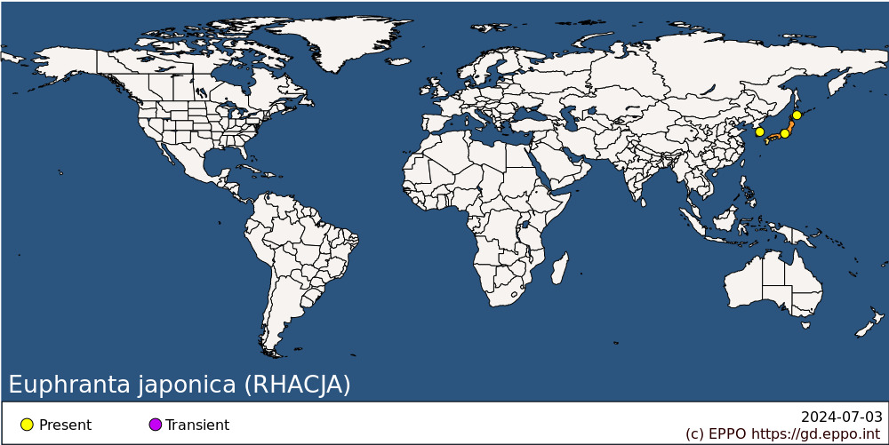
Asia: Japan (Hokkaido, Honshu), Korea, Republic

BIOLOGY
There is no information available on the biology of E. japonica.

DETECTION AND IDENTIFICATION

Symptoms
Not known, but attacked fruit will probably show signs of oviposition punctures.

Morphology
Larva
Not described. Ito (1947) provided a few notes on the larva in his original description [in German].
Adult
Colour: Head, margin of scutellum and legs orange; rest of body black; wing markings brown; wing with a complete apical crossband and no other complete crossbands; anterior edge of wing with two brown markings in cell sc, the basal of which reaches vein R2+3; another mark beyond the end of vein R1 extends to vein R4+5; posterior edge of wing with two markings, one extending forward across the dm-cu crossvein and the other across the r-m crossvein; both these marks only extending as far forwards as vein R4+5.
Head: Three pairs of frontal setae and only one pair of orbital setae; first flagellomere rounded at apex.
Thorax: Scutum without presutural supra-alar setae; scutum with a pair of dorsocentral setae which are placed about half way between anterior and posterior supra-alar setae; scutellum flat, with four marginal setae (one basal and an apical pair); anatergite with long pale hairs which are distinct from the general pubescence.
Wing: Length 5-7 mm. Vein Sc abruptly bent forward at nearly 90°, weakened beyond this bend and ending at subcostal break; vein R1 with dorsal setulae; vein R4+5 with dorsal setulae at least as far as r-m crossvein; apex of vein M meeting C with a distinct angle; cell cup broader than half depth of cell bm, and usually about as deep as cell bm; cup extension short, never more than one fifth as long as vein A1+Cu2, and vein CuA2 straight along anterior edge of cup extension.
Abdomen: Female with an ovipositor that is shorter than the wing length, and straight. Wing length 5-7mm.

Detection and inspection methods
Although trapping methods have been developed for many tephritid quarantine pests, none have been reported for E. japonica.

PATHWAYS FOR MOVEMENT
Not documented, but E. japonica could presumably be carried as puparia in soil accompanying host plants or as larvae in fruits on host plants. There is no record of interception of E. japonica for the European Union (European Commission, 2022).

PEST SIGNIFICANCE

Economic impact
Although E. japonica was regarded as a pest by Watanabe (1939), Koyama (1989) did not mention it in his review of Japanese pest species, suggesting that its status as a pest is minimal. No further details are available. There is no mention of E. japonica in recent scientific literature.

Control
No information, though general methods for fruit fly control would presumably be applicable.

Phytosanitary risk
There is very limited information on E. japonica. Its lack of economic importance suggests that there is no justification for listing it individually as a quarantine pest. Measures against other fruit flies present in the EPPO region (e.g. Drosophila suzukii, Rhagoletis cerasi) are likely to limit the potential establishment and impact of E. japonica if it was introduced into the EPPO region (EPPO, 2022).
EFSA (2020) in a risk categorization for all non-EU Tephritidae listed E. japonica among the species that satisfy the criteria that are within the remit of EFSA to assess for them to be regarded as potential Union quarantine pests.

PHYTOSANITARY MEASURES
No specific phytosanitary measures seem to be justified however, measures similar to those suggested for Rhagoletis indifferens may be applied to limit the risk of introduction: consignments of cherries (Prunus avium, P. cerasus) from regions where the pest occurs should be inspected for symptoms of infestation and those suspected should be cut open in order to look for larvae; fruits should come from areas where the pest does not occur, or from a place of production found free from the pest by regular trapping before harvest and plants of host plant species transported with roots from regions where the pest occurs should be free from soil.

REFERENCES
EPPO (2022) Drosophila suzukii. EPPO datasheets on pests recommended for regulation. Available online. https://gd.eppo.int/taxon/DROSSU/datasheet
EFSA Panel on Plant Health, Bragard C, Dehnen-Schmutz K,Di Serio F, Gonthier P, Jacques M-A, Jaques Miret JA, Justesen AF, Magnusson CS, Milonas P, Navas-Cortes JA, Parnell S, Potting R, Reignault PL, Thulke H-H, Van der Werf W, Vicent Civera A, Yuen J, Zappalà L, Bali EM, Papadopoulos N, Papanastassiou S, Czwienczek E, MacLeod A(2020). Pest categorisation of non-EU Tephritidae. EFSA Journal 18(1), 5931, 62 pp. https://doi.org/10.2903/j.efsa.2020.5931
European Commission (2022) Europhyt/Traces. Interceptions of harmful organisms in imported plants and other objects. https://ec.europa.eu/food/plants/plant-health-and-biosecurity/european-union-notification-system-plant-health-interceptions-europhyt/interceptions_en (last accessed 2022-05).
Hardy DE (1983) The fruit flies of the tribe Euphrantini of Indonesia, New Guinea, and adjacent islands (Tephritidae: Diptera). International Journal of Entomology 25, 152-205.
Ito S (1947) Eine neue Rhacochlaena-Art aus Japan. Mushi 18(8), 35-38.
Ito S (1983-5) The Japanese fruitflies. 1983, 1-48; 1984a-e, 49-96, 97-144, 145-192, 193-240, 241-288; 1985, 289-352. S. Ito, Osaka, Japan.
Koyama J (1989) Pest status; south-east Asia and Japan. In: World crop pests 3(A). Fruit flies; their biology, natural enemies and control (Ed. by Robinson, A.S.; Hooper, G.), pp. 63-66. Elsevier, Amsterdam, Netherlands.
Wang X-J (1996) The fruit flies (Diptera: Tephritidae) of the east Asian region. Acta Zootaxonomica Sinica 21, (Supplement).
Watanabe C (1939) [On the parasitic wasps of fruit flies attacking cherry]. Oyo-Dobutsugaku-Zasshi 11, 123-128.

ACKNOWLEDGEMENTS
This datasheet was revised in 2022 by the EPPO Secretariat. Only a very limited number of scientific references have been published since the last edition of the datasheet.

How to cite this datasheet?
EPPO (2024) Euphranta japonica. EPPO datasheets on pests recommended for regulation. Available online. https://gd.eppo.int

Datasheet history
This datasheet was first published in the EPPO Bulletin in 1983 and revised in the two editions of 'Quarantine Pests for Europe' in 1992 and 1997, as well as in 2022. It is now maintained in an electronic format in the EPPO Global Database. The sections on 'Identity', ‘Hosts’, and 'Geographical distribution' are automatically updated from the database. For other sections, the date of last revision is indicated on the right.
CABI/EPPO (1992/1997) Quarantine Pests for Europe (1st and 2nd edition). CABI, Wallingford (GB).
EPPO (1983) Data sheets on quarantine organisms No. 41, Trypetidae (non-European). EPPO Bulletin 13(1). https://doi.org/10.1111/j.1365-2338.1983.tb01715.x

