EPPO Datasheet: Torradovirus marchitezum
Last updated: 2022-12-09

IDENTITY
Preferred name: Torradovirus marchitezum
Taxonomic position: Viruses and viroids: Riboviria: Orthornavirae: Pisuviricota: Pisoniviricetes: Picornavirales: Secoviridae: Torradovirus
Other scientific names: ToMarV, Tomato apex necrosis torradovirus, Tomato apex necrosis virus, Tomato marchitez virus
view more common names online...
EU Categorization: A1 Quarantine pest (Annex II A)
view more categorizations online...
EPPO Code: TOANV0

Notes on taxonomy and nomenclature
Tomato marchitez virus (ToMarV) was first described by Verbeek et al. in 2008, as a new virus species isolated from a symptomatic tomato plant in Sinaloa, Mexico. In 2009, following the elucidation of the complete genomic sequence of ToMarV and tomato torrado virus (ToTV), it was proposed to place both species into a newly established genus called Torradovirus, and to assign the latter to Secoviridae, a new family of plant viruses (Sanfaçon et al., 2009).
A virus tentatively called tomato apex necrosis virus (ToANV) which had also been isolated from tomato plants in Sinaloa, Mexico (Turina et al., 2007) was subsequently considered to be a synonym of ToMarV (ICTV, 2022). Three other tomato-infecting torradoviruses closely related to ToMarV have been found in the Americas, namely tomato chocolàte virus (ToChV) and tomato chocolate spot virus (ToChSV) in Guatemala (Batuman et al., 2010; Verbeek et al., 2010), and tomato necrotic dwarf virus (ToNDV) in California (Wintermantel et al., 2018). However, it is still unclear whether they are distinct species, three strains of a new torradovirus, or distant strains of ToMarV (Garcia-Estrada et al., 2022; ICTV, 2022). The present datasheet covers ToMArV only, and ToChV, ToChSV, ToNDV have been considered as separate entities, awaiting further clarification on their taxonomic status.

HOSTS
The known host plants are Solanaceae. Natural hosts are tomato and capsicum; in addition, a number of indicator plants could be infected in inoculation studies (Verbeek et al., 2008, Camacho-Beltrán et al., 2015).
Host list: Capsicum annuum, Solanum lycopersicum

GEOGRAPHICAL DISTRIBUTION
ToMarV is only known from Mexico.
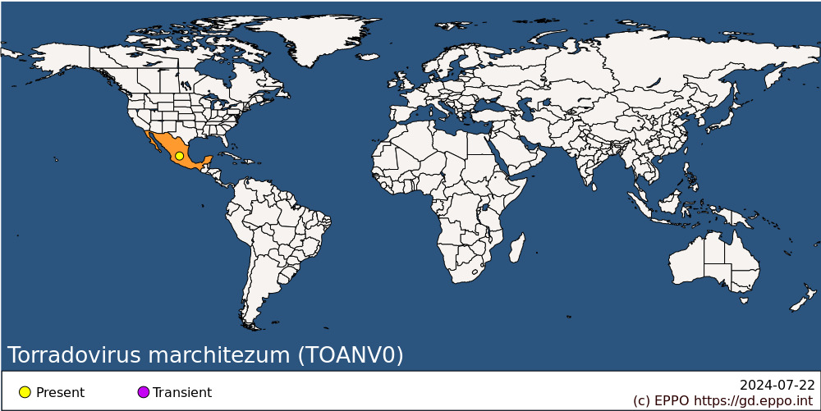
North America: Mexico

BIOLOGY
ToMarV is transmitted by Bemisia tabaci or Trialeurodes vaporariorum whiteflies in a semi-persistent stylet-borne manner. In experiments, it could also be transmitted by Trialeurodes abutiloneus (Verbeek et al., 2014). The insect should feed for at least 2 hours on an infected plants before being able to transmit it to a healthy plant. The vector can remain viruliferous for at least 8 h. However, if they feed on a non-host plant for 8 h, they lose the ability to transmit the virus (Verbeek et al., 2014).

DETECTION AND IDENTIFICATION

Symptoms
Symptoms are similar to those caused by tomato torrado virus (ToTV). Typical symptoms observed on tomato are leaf necrosis beginning at the base of the leaflets, as well as dark necrotic rings on the fruits, already visible on the unripe green fruits. In severely infected plants, the top of the plant shows necrosis and malformation. In Mexico, this disease is known as ‘marchitez’, meaning wilted or withered (Verbeek et al., 2008). Other symptoms include growth delay, necrosis of flowers, necrotic leaf spots, and corky fruits (García-Estrada et al., 2022). On capsicum, the symptoms observed were yellow mosaic, upward leaf curling, and crinkling on leaves and stunting of the whole plant (Camacho-Beltrán et al., 2015).

Morphology
Torradoviruses possess small spherical virions, approximately 30 nm in diameter, composed of three coat proteins of approximately 23, 26, and 35 kDa (van der Vlugt et al., 2015). ToMarV consists of two molecules of positive single-stranded RNA.

Detection and inspection methods
RT-PCR tests are available to identify the virus (García-Estrada et al., 2022).

PATHWAYS FOR MOVEMENT
Spread is predominantly with viruliferous whiteflies. ToMarV can also be transmitted by mechanical inoculation.
In international trade, ToMarV may be carried by infected plants for planting. Import of plants for planting of Solanaceae is regulated in the European Union (EU) and in some non-EU EPPO countries and the introduction of non-European populations of B. tabaci is forbidden in the EU.
No information is available on seed transmission of ToMarV. Seed seems to be a possible pathway for tomato torrado virus (ToTV), a closely related torradovirus but was not demonstrated for others closely related torradoviruses such as tomato necrotic dwarf virus (van der Vlugt et al., 2015).

PEST SIGNIFICANCE

Economic impact
Substantial economic losses were reported on tomato due to the inhibited growth of the tomato plant and to the unmarketable fruits (Turina et al., 2007; Verbeek et al., 2008, García-Estrada et al., 2022). Although capsicum was reported as a natural host in 2011, no economic impact was reported (Camacho-Beltrán et al., 2015).

Control
Control of the disease caused by ToMarV relies on the use of healthy plant material, elimination of the infected plants, and the control of whitefly populations. Although no weed species are documented as hosts, control of weeds inside and near the production areas is usually important to remove any potential reservoirs of inoculum.

Phytosanitary risk
ToMarV caused losses in tomato production where it was reported. It was once considered as an emerging damaging virus but no reports in other countries have been made since the first reports in Mexico in 2007 -2011. García-Estrada et al. (2022) list ToMarV as a virus of economic importance in tomato production in Mexico.
If introduced into the EPPO region, ToMarV could probably establish. However its potential impact is difficult to assess as existing measures to control whiteflies and other viruses may reduce its impact.

PHYTOSANITARY MEASURES
The import of Solanaceae plants for planting is prohibited in many EPPO countries. To prevent the introduction of this virus in countries where it is not prohibited, plants for planting should be tested or come from a pest-free area for ToMarV. There is no data on seed transmission, and therefore it is not known if measures should be applied on seed of host plants.

REFERENCES
Batuman O, Kuo YW, Palmieri M, Rojas MR, Gilbertson RL (2010) Tomato chocolate spot virus, a member of a new torradovirus species that causes a necrosis-associated disease of tomato in Guatemala. Archives of Virology 155(6), 857-69. https://doi.org/10.1007/s00705-010-0653-9
Camacho-Beltrán E, Armenta-Chávez R, Romero-Romero JL, Magallanes-Tapia MA, Leyva-López NE, Apodaca-Sánchez MÁ, Méndez-Lozano J (2015) First report of pepper as a natural new host for Tomato marchitez virus in Sinaloa, Mexico. Canadian Journal of Plant Pathology 37(3), 384-389.
EFSA (2013) Scientific Opinion on the risks to plant health posed by Bemisia tabaci species complex and viruses it transmits for the EU territory. EFSA Journal 11 (4), 3162. https://doi.org/10.2903/j.efsa.2013.3162
García-Estrada RS, Diaz-Lara A, Aguilar-Molina VH, Tovar-Pedraza JM (2022) Viruses of economic impact on tomato crops in Mexico: from diagnosis to management—A review. Viruses 14(6), 1251. https://doi.org/10.3390/v14061251
ICTV (2022) Report Chapters. Secoviridae. Torradovirus. https://ictv.global/report/chapter/secoviridae/secoviridae/torradovirus
Sanfaçon H, Wellink J, Le Gall O, Karasev A, van der Vlugt R, Wetzel T (2009) Secoviridae: a proposed family of plant viruses within the order Picornavirales that combines the families Sequiviridae and Comoviridae, the unassigned genera Cheravirus and Sadwavirus, and the proposed genus Torradovirus. Archives of Virology 154, 899–907. https://doi.org/10.1007/s00705-009-0367-z
Turina M, Ricker MD, Lenzi R, Masenga V, Ciuffo M (2007) A severe disease of tomato in the Culiacan area (Sinaloa, Mexico) is caused by a new picorna-like viral species. Plant Disease 91(8), 932-941.
van der Vlugt RA, Verbeek M. Dullemans AM, Wintermantel WM, Cuellar WJ, Fox A, Thompson JR (2015) Torradoviruses. Annual Review of Phytopathology 53, 485-512.
Verbeek M, Dullemans AM, Van den Heuvel JF, Maris PC, van der Vlugt RA (2008) Tomato marchitez virus, a new plant picorna-like virus from tomato related to tomato torrado virus. Archives of virology 153(1), 127-134.
Verbeek M, Dullemans A, van den Heuvel H, Maris P, van der Vlugt R (2010) Tomato chocolàte virus: a new plant virus infecting tomato and a proposed member of the genus Torradovirus. Archives of Virology 155(5), 751-755. https://doi.org/10.1007/s00705-010-0640-1
Verbeek M, van Bekkum PJ, Dullemans AM, van der Vlugt RA (2014) Torradoviruses are transmitted in a semi-persistent and stylet-borne manner by three whitefly vectors. Virus research 186, 55-60.
Wintermantel WM, Hladky LL, Cortez AA (2018) Genome sequence, host range, and whitefly transmission of the torradovirus Tomato necrotic dwarf virus. Acta Horticulturae 1207, 295-302.

ACKNOWLEDGEMENTS
This datasheet was prepared in 2022 by the EPPO Secretariat.

How to cite this datasheet?
EPPO (2024) Torradovirus marchitezum. EPPO datasheets on pests recommended for regulation. Available online. https://gd.eppo.int

Datasheet history
This datasheet was first published in 2022. It is maintained in an electronic format in the EPPO Global Database. The sections on 'Identity', ‘Hosts’, and 'Geographical distribution' are automatically updated from the database. For other sections, the date of last revision is indicated on the right.

